**Ch. 1: Introduction**

* 1. **Technological context**

Globalization. One question that is not asked enough would be: has the Internet appeared and evolved so greatly due to globalization or has the globalization increased with such rapidity because of the most powerful means of communication on the planet: the Internet. We have all heard the stories about the inception. It all started with a few computers, bound together to allow communication on a single network, creating what the early visionaries would call “the network of networks” [1] and what we identify today as the Internet.

Since then, the world evolved so much, that nowadays, technology took over almost every aspect of our lives. People read the news, buy clothes and search for places online. Having this in mind, there’s no wonder the most used applications are web-based. Either on mobile or on desktop, websites are a strong competition for mobile applications.

The most important quality held by web applications is their flexibility as they can be used in any web browser, even on mobile. Because of the low development cost and the fact that today, technology evolved so much, due to the appearance of HTML5, browsers became just as fast and reliable as native applications and companies and individuals count more on websites than any other form of application.

Since the mobile development has increased, the mobile usage is starting to surpass the desktop. Being portable is one of the greatest factors for this trajectory that mobile phones took. It is, indeed, easier to check your email, for example, on a small device that most people carry anywhere than to wait until you can access a laptop, personal computer or tablet. However, there is a field in which desktop websites win over mobile websites accesses: engagement. People tend to spend more time on a site from a laptop compared to mobile. Following the same logic, when it comes to online shopping, people also buy more from desktop websites. To put it into perspective, let’s call for the way it is easier to understand: numbers. The most recent and valid statistics are from 2019 and they show that, on the same site, users spend 40.1% of the time using a phone and 55.9% using non-mobile devices [2]. Although desktop websites surpass the mobile ones, we can’t neglect the high number on both sides. Mobile devices are also very present, being used in 55% of Google searches, while 40% of people search only on their smartphones [3]. According to gs.statcounter.com [4], in Romania, 2019-2020, desktop usage still prevails in front of mobile, but decreasing rapidly and losing in front of mobile users.

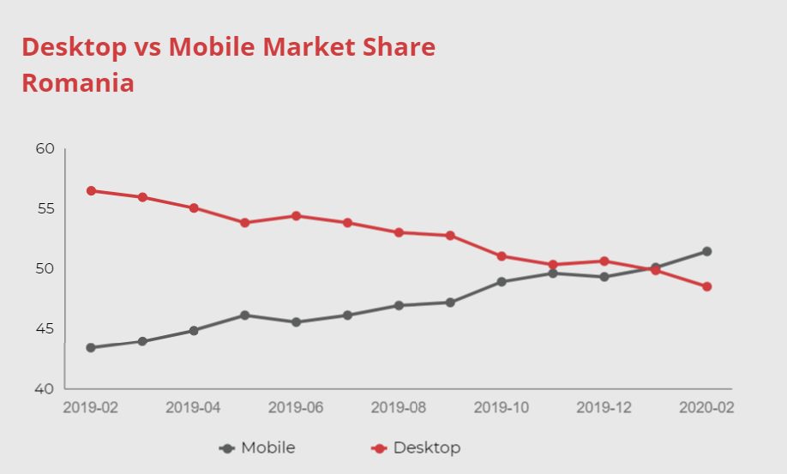

*Figure 1. Desktop vs. Mobile Market Share in Romania (Jan. 2019 – Feb. 2020)*

These statistics are important in the grand scheme of habits that people develop over the internet because they highlight the great importance that responsive websites hold. Responsive means that the website developed can be accessed on any device, having any width, with a neat appearance, structure and style, adding a friendly experience from the user point of view. Nowadays, responsive websites are a must, a necessity, not an option. Any company that asks for credibility must allow their target group of persons, access their website from any device.

* 1. **Problem Definition**

In the context presented in the last chapter, I briefly defined how a web application fits in the whole picture of web development and the best devices to focus upon according to the type of application developed. In this paper, I will present the evolution development of a web-based event organization application.

We can admit that throughout a person’s life, there are a few major events that need consistent and fairly great efforts and resources. Especially in Romania, a country in which the citizens’ beliefs count a lot on religion and tradition, people invest a lot of time and money into these events, such as weddings or baby christenings. Choosing a venue or clothes is very stressful for the people involved. It takes a lot of calls and places to visit in order to make the final decision regarding every element constituting in the event. And, unfortunately, this field is still not very computerized and, therefore, a lot of time is lost on actions and activities that can be avoided by using a program to manage the budget, make appointments or choosing what you need for the event from many options presented. This would improve the whole process significantly and it would give the chance to the organizers of the events to focus more on the event itself and enjoy it, rather than stress about it.

All these arguments together, drove me to choose this project theme for my bachelor thesis, so I have one question on which my premise is based: in today’s time, people order from the Internet clothes, food and even groceries, so why not order the events online too?

* 1. **Project Scope**

Summing up the information presented before, the objectives of this paper and project is to highlight the advantages brought by a web application destined towards people who want to organize events, however small or big. This paper discusses the planning management issues in the context of people’s important events in their lives, how a web platform would make it more facile for everyone in this position of handling an event and, finally, it proposes a software application, PlanNow, specialized in this organizational process, easy customable for users’ needs, that will solve a lot of problems in this field.

PlanNow can be used by any user that accesses the website and creates an account. The application will be hosted by company organizing events that have contracts with different companies and venues that are to be offered to users for their choosing. An admin will handle the internal affairs regarding CRUD operations on venues, catering companies and so on, but the most important part will be the users’ side. This will consist of going through every step of the organizing process, all online, by seeing possible venues, their photos and details and, ultimately, choosing one that fits the desired target. Also, choosing food, clothes, entertainment, etc. This whole choosing process is a very well thought one, prepared by experts in this fields, that made sure that no detail will be missed from the platform in regards to event planning. Another important feature will be the fact that everything will be displayed on page based on the users’ preferences from a profile they need to complete beforehand. This will be a recommender system based on social data in terms of what is popular in the age group the person is from or their background.

The main benefits why people should focus their attention on an event planning web platform are:

* Save, otherwise lost, time
* Sure management of money
* Having access to many tools and locations that could be otherwise overlooked
* Most of the organizational part of the job is done for you, by the application
* Less stress, more enjoying the actual event
* There is a high indication to digitalize and keep up with the new technology in this field
* It has a positive impact on the invitees
  1. **Structure of the paper**

The paper will contain the main titles as listed below:

1. Introduction

2. State of the Art

3. The research methodology used in order to establish the application requirements

4. The presentation of proposed application

5. The technological choices and a short presentation on why they were chosen

6. Validation of the final product

7. Conclusions and further improvements

8. References

This report accompanying the practical application, PlanNow, will be structured in 4 important parts. The introduction I am currently presenting, state of the art where there will be presented theoretical background of the problem and some existing websites that are similar to the one I am developing, then will come a part where I will discuss the functionalities and their technologies that I used in the development process and how I implemented them, adding afterwards the proper description of the application.

The validation chapter describes the feedback received from the users that have tested the application, by using a Google Form to collect the results.

The conclusions chapter summarizes the outcomes and the results drawn, based on which some future improvements can be developed for further improving the application’s functionalities.

**Ch. 2: State of the Art**

**2.1. Technology and user needs**

Technology has always been serving users for the purpose of fulfilling certain needs. Either the need for the technology to evolve or so it will come useful for the users’ demands. Web development is mainly used for the purpose of making it easier for users to accomplish certain tasks.

A planning application is a platform that allows the users to keep all of their details about their upcoming events in one place, organize them neatly and easily keeping track of the whole process using a list of tasks that need to be done created by people with experience in this field and making sure everything goes well accordingly.

However, when you look up for event planning apps on the Internet, you will probably be surprised that the most common search results will be advertisements towards event planning companies or websites where there are presented future events near your area. The few platforms that actually help you organize them are few and offer not so many functionalities towards creating the perfect event. The reason for this would be because most companies choose to operate in the old school way, instead of investing more money in a business that already brings profit. Therefore, the losing team here is the users’, the people that have to lose time on the phone and on meetings just so they can have the event they have always dreamed about.

Let’s put it this way: how many people do you know that have planned at least one event in their lives using an application where they can choose every detail they need? I, personally, don’t know any. Besides the big corporations that have started using applications in order to set up their important meetings, planning apps are not that popular. Firstly because there are few apps like that on the market and secondly because those that exist are not very efficient, so, as a consequence, they are not strongly promoted in order to become known to that many users.

Therefore, this kind of website that will take care of every aspect of an event for the user would be extremely needed and would be received well by the public. It could become immensely popular and it has the potential to make enough profit to cover so much more than the investment put into developing the application, by increasing the sales for a lot of partner companies and the event planning agency itself. For these reasons, the platform I am developing, PlanNow, is need-driven.

In conclusion, in the past, choosing how to organize an event was purely a problem between the organizers and suppliers or retailers. Now, there are a few apps that come to help in planning events, but it’s not that common to use them and I want to bring this app to the attention of ordinary people.

**2.2. Similar applications**

In the next part, I will present 5 applications that are similar to mine, PlanNow, by using different criteria: a description for better understatement of it, what functionalities it offers to its users, how easy it is to be used, advantages and disadvantages and, finally, a comparison to PlanNow.

**2.2.1. EpicPlan**

**Description**

EpicPlan is a web platform that is destined towards managing events and keeping track of a list of tasks that need to be done for the event to take place in the best circumstances. It is helpful to use for some aspects of the event that is planned and it has a neat and pleasing design and architecture.

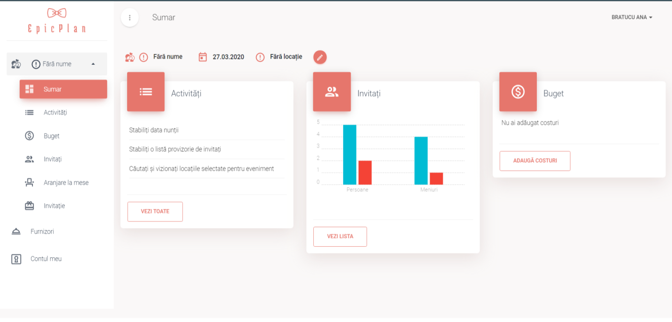 *Figure 2. Event summary page from the EpicPlan website*

**Functionalities**

Started from the beginning, after being prompted to create an account, you can create an event out of four types: wedding, christening, birthday party or corporate party. Afterwards, it is possible to estimate your budget, create an attendees list and arrange them at tables and create invitations. An important aspect is the predefined to do list with the most important activities that must be accomplished before the event and on which, the tasks can be checked after they are done. All this progress can be seen on the Summary page.

**Usability**

This application is not so hard to use, the maximum time it would take any person to accommodate to the interface being around 10 minutes, this including seeing and testing all of the functionalities. However, there were certain things that were not very intuitive to discover. For example, I had to look around in every page from the website in order to find out how I can edit the name of the event or to delete it.

**Weak points**

* As I have mentioned above, some functionalities were a little bit hard to find.
* Only four type of events to choose from
* The template and functionalities for each type of event are the same, either I am planning a wedding or a corporate party.
* Too little functionality.
* Does not let you change the order of tasks in the to do list.

**Strong points**

* Easy and simple template and design.
* The table arrangement is facile and intuitive to use.
* Useful statistics regarding what it is done in the organizing process.
* Useful graph of all of the attendees invited and who confirmed their presence and who did not.

**PlanNow vs. EpicPlan**

**Similarities**

* All of the functionalities from EpicPlan are found in PlanNow, except the task list
* It is a Romanian website from and for Romanians.

**Differences**

* PlanNow allows users to make a lot more key decisions regarding their events, such as book the venue, choosing their food and drinks menu, consult clothes stores for the attire they want to wear or to plan private events in private homes with catering.
* PlanNow allows users to choose from more types of events ( ).
* PlanNow has a functionality where the budget will be updated automatically from the operations the user does, like booking a venue, order a wedding dress and so on.

**2.2.2. Eventbrite**

**Description**

Eventbrite is also a web platform for events, but it is more inclined towards promoting events added by users to be seen by other users who can order tickets online and also organizers have a management tool where they can see event reports, due payments and supervise partners (mostly venues).

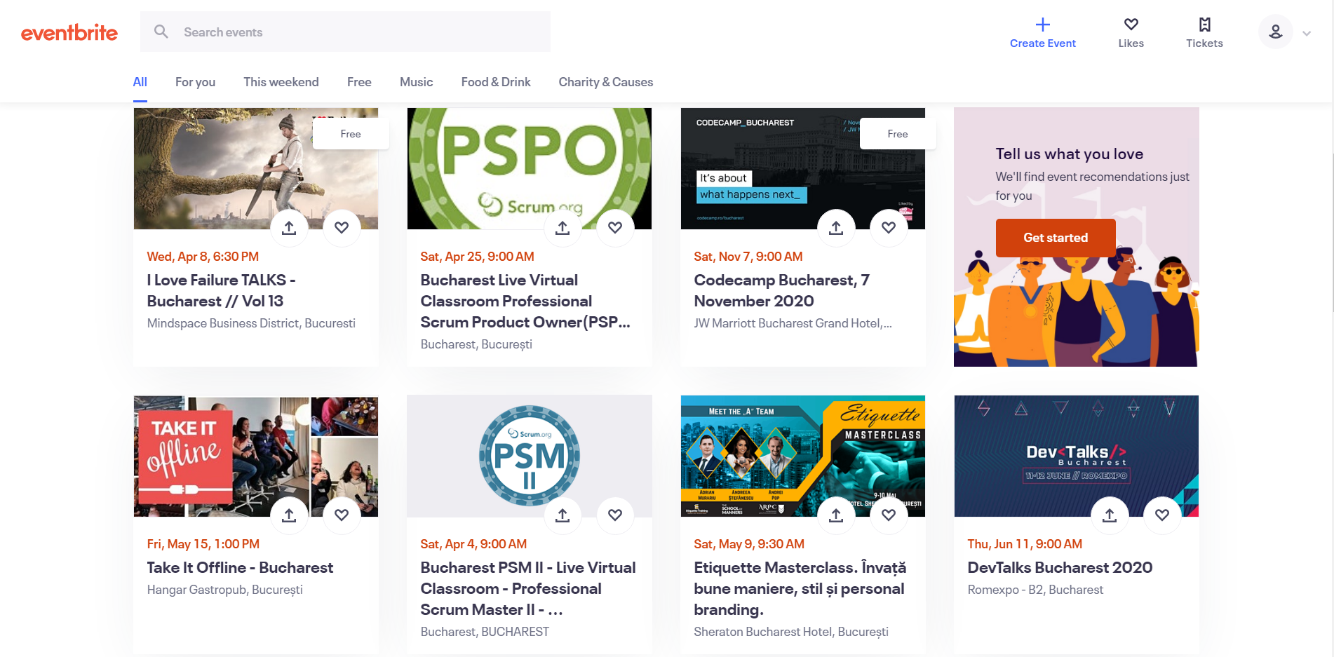*Figure 3. Event browsing page from the Eventbrite website*

**Functionalities**

This website application is complex and it is addressed to many categories of users, having a lot of functionalities to be used depending on what every person is looking for. First of all, after registering, it is available to browse already added events. Once they are clicked, purchasing tickets to those events is available. Users can also add events that are already planned beforehand by completing every detail and publishing it on the website, being able to promote it after. As an organizer, the platform offers a grand area of settings to be managed, such as charges, taxes, partner venues and other partner organizers, creating an easy and straightforward link between them in order to make it simple to collaborate in the future as well. Likewise, there is possible to come in contact with new contacts to help them plan future events.

**Usability**

This platform has a well-constructed design that helps user find the most personalized events they would be interested in. Yet, when it comes to the organizer part of the website, things are not the same. Although, the design is still very pleasant, it is hard to find your way around to keep up with every tab and detail that is being presented on each page. In conclusion, to get accommodated to this part of the website would take using it at least two times for about fifteen minutes and try out every component. So, the platform should become more intuitive after testing it and having more personal experience with it.

**Weak points**

* A definite weak point is finding it hard to understand how to manage the events as an organizer.
* Eventbrite is not free to use for organizers and the fee is 50% from tickets sold, which is not attractive at all.

**Strong points**

* Buying tickets is unquestionably fast and clear.
* There are a lot of reports for payments or ticket sales that are very useful for organizers.
* Promoting the events is productive and helpful.

**PlanNow vs. Eventbrite**

**Similarities**

* Both allow users to create events.
* Both allow organizers to create attendees list.

**Differences**

* PlanNow does not allow users to browse added evens by other users, like Eventbrite; all of our events are private, with a clear list of attendees.
* PlanNow allows users to set the details to their own event and also manage them.
* PlanNow gives its users complete access to all of the functionalities for free, only perceiving a commission fee after the event is fully planned that goes towards the planning agency that owns the platform.
* PlanNow allows users to arrange attendees by tables and send emails and updates to them.

**2.2.3. Plan it out**

**Description**

Plan it out is a mobile application which proposes a simple template and offers a few important functionalities in planning an event. Something new and different from the other applications presented is the platform it operates on. It is destines for Android and it can manage small to large events all the same.

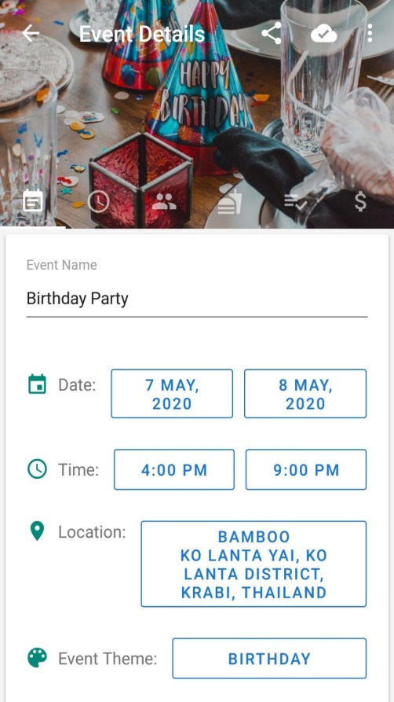

*Figure 4. Creating a new event on Plan it out mobile application*

**Functionalities**

Plan it out has a friendly interface on which the users can find the most important services when it comes to events. So, there’s a list of all the events the users are managing, editing existing events is effortless and people who use the application are able to add an itinerary, add gusts, add food and drinks they set to consume at the event and task list because it is important to keep track of the things it is needed to do. All these actions are back up by a budget management and the users can add every expense they make during the organizing process, so they don’t exceed their limit, keeping in mind any kind of event is costly and can bring you trouble if not careful.

**Usability**

This platform is user friendly and although it has sufficiently functionalities, it manages to order them in a logic manner and it is easy to understand the interface faster than most applications. That being said, it is necessary to mention that an average person can accommodate to this application in no longer than five minutes. That would be enough for them to see what it is about and what it can do and then proceed to create their own events.

**Weak points**

* Every cost, decision or acquisition must be declared manually and it is hard to keep up with everything that needs to be done in this way.
* The application does not offer to choose.
* This is again just an application where users can manage already planned events or partially planned events, not where they can actually plan and go through the event process using it.
* There are a lot of ads appearing on the screen which slows down the users from what they need to do and that costs their time.

**Strong points**

* Attendees can be chosen by phone number from the phone’s contacts list.
* The food and drinks menu can be composed fast and organized by food type and meal course.
* Itinerary is an aspect rarely seen in event planning applications, so it is an advantage considering people can use it in a multitude of ways.
* Details can be imported from previous events.

**PlanNow vs. Plan it out**

**Similarities**

* Users can add, edit and delete events.
* Users can plan a budget from which it is subtracted the spent money after purchasing items.
* Events can be shared on social media.

**Differences**

* PlanNow facilitates the planning event and almost everything can be done on this platform without losing any more time, so not only that PlanNow is a management tool for events, just like Plan it out, but also is a planning tool.
* PlanNow has contracts with many companies of clothes, catering or entertainment from which the users can choose for their memorable events.
* Unlike Plan it out, PlanNow has the operation of sending invitations.
* On the PlanNow platform, the budget is updated dynamically depending on the purchases made by the user on the application.

**2.2.4. TopTablePlanner**

**Description**

TopTablePlanner is an atypical planning application. The area it specializes in is the table arrangements from the events. I found it worth mentioning because it is an important functionality to be able to sit the invitees at each table however the users want.

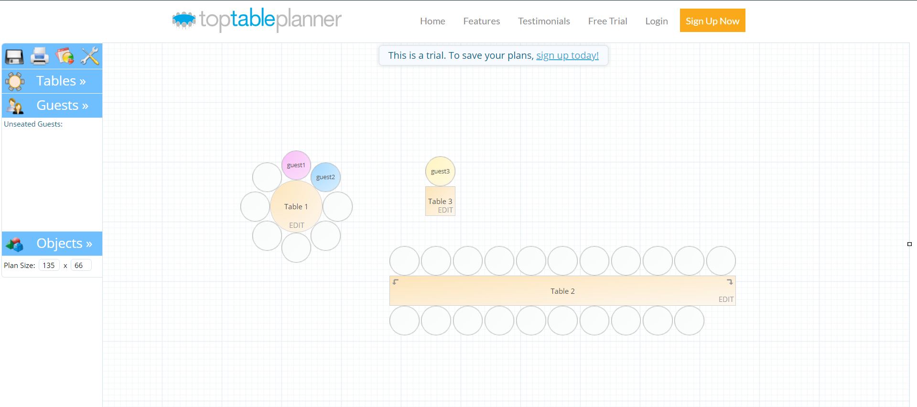

*Figure 5. Table arrangement on TopTablePlanner application*

**Functionalities**

TopTablePlanner is a very simple application, its layout is nothing too complicates, but its use is one that not every event planning application has. It is special in how user friendly it is put the tables on the canvas however the user wants and place every invitees to them. The whole application consists of a single page where users can find everything they need. As it can be seen in the figure above, on the left menu, users can choose different types of tables, with different sizes and shapes. Also, it can be chosen the number of seats for each table. After choosing them, they can be placed around the canvas for the users’ liking. Afterwards, guests are added, with the mention of their gender, type of menu they prefer and if they confirmed the attendance already or not. The guests can be deleted, edited and searched for in the list where they are added to. Automatically, guests will be available to be placed at the tables from the canvas using drag and drop. Another important feature is the fact that the plan size can be changed depending on the venue they will be having and other type of objects can be added so the plan will resemble more to the actual room the event will take place at.

**Usability**

TopTablePlanner is easy to understand because it is a one page website and does not distract users’ attention with a lot of different elements on the page, keeping it simple and to the point. Time to accommodate to it lasts as long as the user can take in the few tabs from the left menu, which should not be longer than one minute on average.

**Weak points**

* One downfall for this platform is that the design is rather dull and it looks more like a game than the actual important tool it is.
* The application is not free; users can only have a trial version available before buying a subscription plan.

**Strong points**

* It is important to know that the tables can be edited even after adding attendees to its seats.
* Being able to print the final scheme of seating arrangements.
* There are also a lot of useful statistics regarding the tables and what menus the invitees prefer and this are important details for someone organizing an event.
* Those reports can also be exported in CSV format.

**PlanNow vs. TopTablePlanner**

**Similarities**

* PlanNow and TopTablePlanner have in common being able to add, edit and delete guests and also the seating arrangement.

**Differences**

* Of course, PlanNow is very different from the TopTablePlanner application because of the many more functionalities available for PlanNow, but I chose this application to analyze because I want to highlight the importance of seating arrangements and the fact that other applications lack for features in this department, resulting in the consequence of not having one application on the market that has everything the users need for planning an event, like PlanNow.

**2.2.5. Venuu**

**Description**

Venuu is a venue search engine where people can find more than 1000 venues from all over the world. These venues are added by anyone that owns one and it is a great way to promote it for people who are looking for places to host their events.

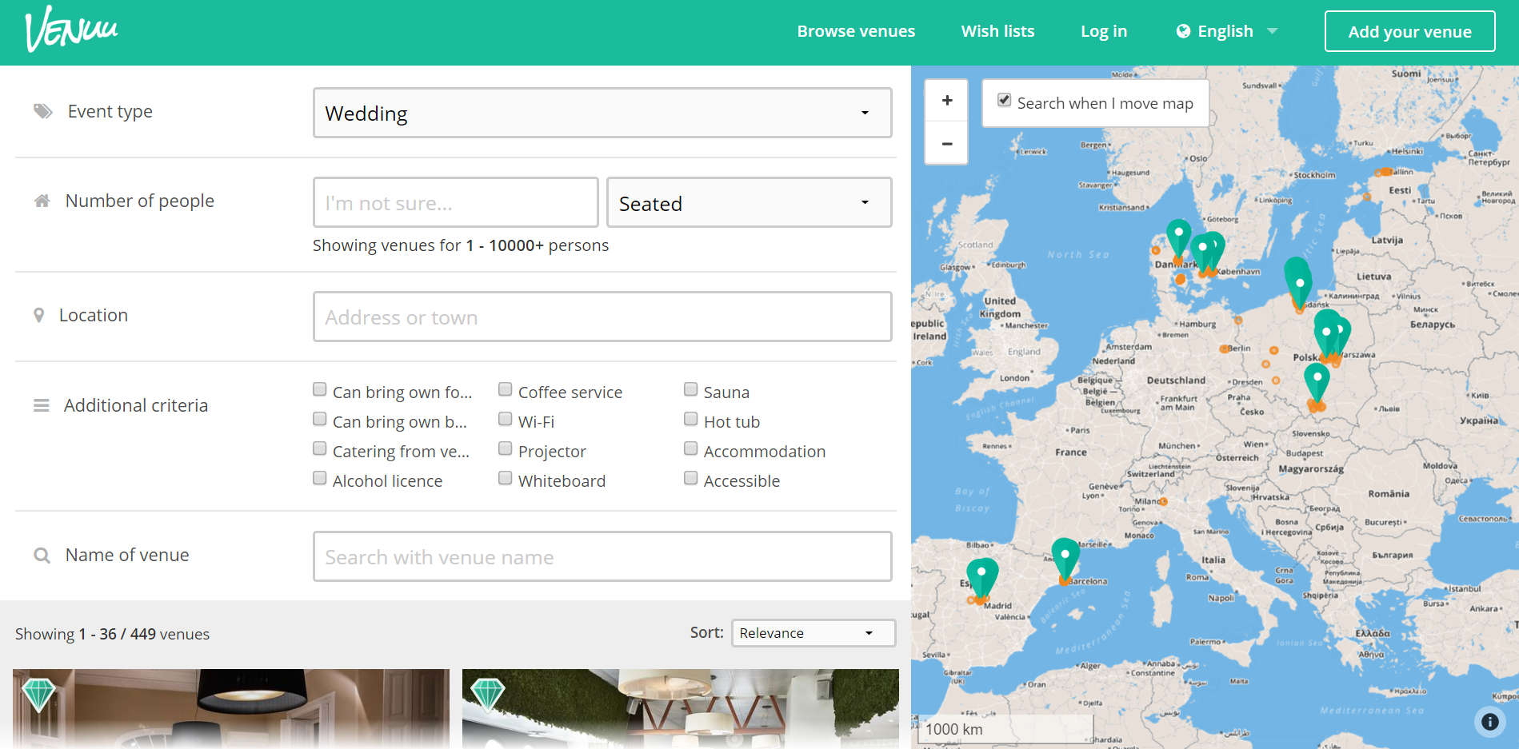

*Figure 6. Browsing venues page on Venuu website*

**Functionalities**

Venuu is a great opportunity to promote venues, for those who need it, and also find them very easily with just a few clicks. It is very accurate because of the specific filters, making it perfect for people who are looking for something in particular and, at the same time, for people who do not know what they need or want. The map gives great insight over the clear place the venue is located at and there is a good description of the venue once you select one that fits your standards. As I mentioned before, people can add their own venues very fast and with no troubles and users can contact venue owners by sending messages to them from the application so they can find out if the venue is available for the specific date they would need it. This way, they will receive via email a proposal which they can accept or not. This is how booking is done. Users can add venues to a wish list for future reference.

**Usability**

It is a great intuitive platform and everything is clearly situated on each page so each element can be found without much effort. The estimated accommodation time is ten minutes.

**Weak points**

* Most of the venues are located in Northern Europe, making it almost useless for Romanians.
* Lost time over message sending; booking cannot be done online.
* Rating does not work despite the fact that star icons are shown at every venue.
* Reviews cannot be added.

**Strong points**

* Six languages available.
* Many event types to choose from.
* Anyone can add their venues.

**PlanNow vs. Venuu**

**Similarities**

* Venue search and browse are similar.

**Differences**

* PlanNow allows users to rate venues.
* PlanNow allows users to search for venues in a specific period of time and displays only the ones that are free during that interval without losing the users’ time to look for venues that could be available.
* PlanNow allows users to book the venues directly and the users know the exact cost of renting that space beforehand.
* PlanNow does not give users the opportunity to include venues to a wish list.

**2.3. Conclusions**

In conclusion, I tried to choose the most relevant applications for my purpose to show the most similar to the one I developed and compare them to highlight where PlanNow could fit into the market. I tried to extend my research to mobile application, as well, in order to have the most correct idea of the current market stage when it comes to planning apps. A market of planning events where online platforms are still reticent looked upon, with the idea that events are so complex that they cannot be organized from behind a desk. That is the reason all of the applications presented above, which are also the most popular, lack a lot of details and functionalities that could be easily included and used for users’ benefit.

**Ch. 3: Research Methodology**

**3.1. Requirements Analysis**

**3.1.1. Survey**

The research is an important part when beginning to create a new product because it is necessarily to find its place on the market and to determine in what way it will affect the users. The drive for creating PlanSaver came from an idea that it is a lack of such applications in this certain field and that it would bring a surplus of commodity in the today’s busy society.

But in order to gain the pulse of the possible future users, a market research was conducted to find where the targeted clients situate themselves in report to online planning events applications and if they would be open to try it. It is well known that the most major events in a person’s life is of very high importance and they tend to be offered substantially attention and effort. But are people ready to give this task and responsibility to an application?

A survey was created which was distributed to various classes of people, each in different age groups and backgrounds, in order to make the study as accurately as possible and to have a wide range of responses from which it can be drawn a very clear conclusion. The research was done using an online survey tool from Google Forms, which generates precise interpretations of the given answers to single choice questions. These kinds of questions, in addition to the fact that it is anonymous and easy to access, gave the responders a facile and safe space to give their opinions.

The responders were in number of 39 persons in all types of categories ranging from young people to older ones in both rural and urban conglomerations. The subject was web based planning events applications in general to see how people see them and what can be improved regarding them putting in balance their personal experiences.

The whole length of the questionnaire is attached in the annexes section, at the end of this paper, but next I will provide you with the most relevant answers given by Google pie chart interpretations, so we can further analyze them.

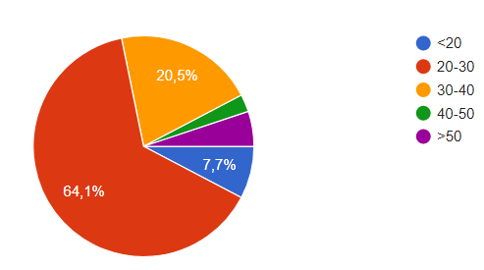**3.1.2. Survey Answers**

* In what age group do you belong to?

It is relevant to specify that 64.1% of responders have the age between 20 and 30 *Figure 7. Pie chart response for question number 1*

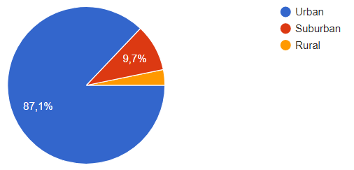years old because this will affect the rest of the responses and we will see how this has an impact on the final resulted conclusions.

* In what area are you living in?

Being important to understand how their backgrounds are tight to the responses, we find that the overwhelming percentage of 87.1% is living in urban areas.

*Figure 8. Pie chart response for question number 2*

* 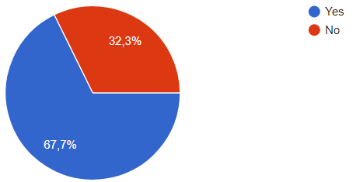People who had to plan for an event vs. those who did not

People who have been in the position of having to organize an event of any kind are in proportion of 67.7% as the survey shows and the rest have not.

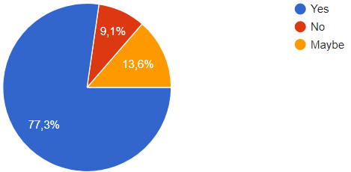 *Figure 9. Pie chart response for question number 3*

The latter category has been asked if they would be open to use an application to help in the planning part and the majority of 77.3% of them have answered with “yes”, with only 9.1% answering with “no”. That means that even *Figure 10. Pie chart response for question 13*

people who did not have anything to do with events before would be open to try such an application.

* People who used an application to plan an event vs. those who did not

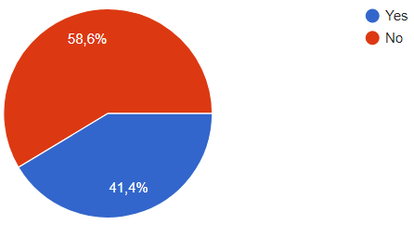 Those who have answered positively to the question “Have you ever used an online app for planning an event?” were also asked how many times that happened, to which the predominant answer was “between 2 and 5 times”, in a percentage of 58.3%, coming close second is the answer “once”, with 41.7%.

*Figure 11. Pie chart response for question 4*

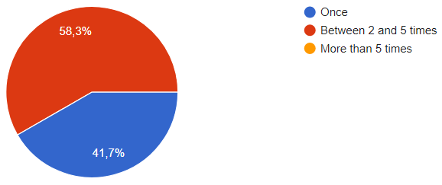

*Figure 12. Pie chart response for question 5*

* Did you find the app useful?

To this, 66.7% of the responders said that “yes” they did find them helpful, to which it is very clear that these kinds of applications made a great impact on its users.

* 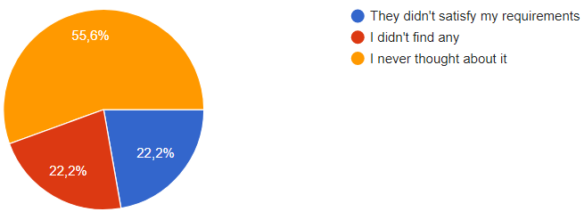What was the reason why you haven’t used a planning app?

Most have answered that they did not think about it, not realizing that this could be an option before, highlighting just how little of promotion there has been before in digitalizing this field. The rest have

*Figure 13. Pie chart response for question 9*

responded in equal number distributed between the answers of “I didn’t find any” and “they didn’t satisfy my requirements”. So not only there aren’t enough applications to make the task of planning an event easier, but those that exist are not complete and useful enough for many people.

* Was the event planning process a time consuming one? (both sides – have not used an app before vs. have used)

From the answers, it can be gathered that people who have not used an application for event planning before are much more prone to think of organizing an event as an activity that takes a long time – 83.3%, in comparison to those that have more experience with these applications who have answered that they do not think of it as such – 60%, with only 10% who view it as time consuming.

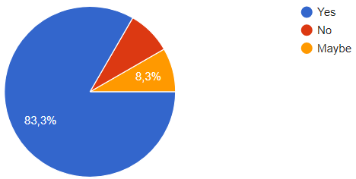

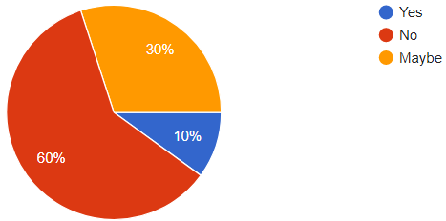

Vs.

*Figure 14. Pie chart response for question 10 Figure 15. Pie chart response for question 7*

* On a scale from 1 to 5, how stressful it was to complete the event planning? (both sides – have not used an app before vs. have used)

In the same manner, people who have not used an application for this purpose of organizing events before, think it is a stressful task, the answers ranging between 3 (moderate stress) to 5 (very high stress), the highest percentage being attributed to the 4 grade (high stress) with 50%. Contrarily, the other group’s opinion (which used an event planning application before) is on the other extreme of the grading system, 45.5% associating event planning with the number 2(merely stress). This is the focal point of the thesis, nuancing exactly the difference a helping application could make in creating an easier life, even in this domain.

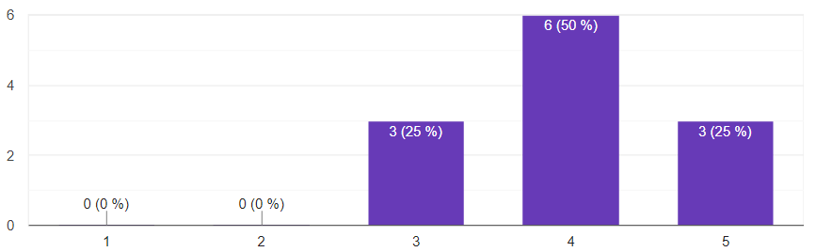

*Figure 16. Bar chart response for question 11*

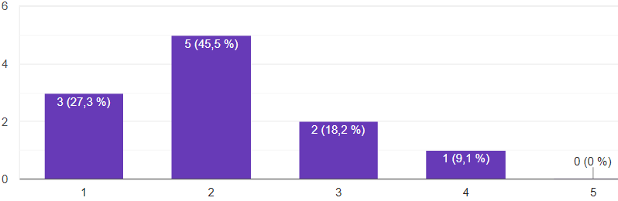 Vs.

Figure 17. Bar chart response for question 8

* Would you ever consider using such an app for organizing an event?

Finally, responders who have not ever used an application for event planning reported, in

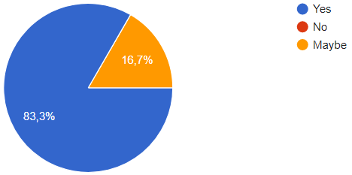proportion of 83.3%, that they would be willing to try them, giving them the trust vote and a bigger encouragement in the market.

*Figure 18. Pie chart response for question 12*

**3.1.3. Survey Conclusions**

The feedback from the persons answering the survey has only strengthened my initial premise that stated that existing event planning applications have not made a breakthrough in the market and there is an immense need for them, even though people have not realized it because they do not think it can be possible. The questionnaire shows that even the predominant young age category in which most respondents are in, 20-30 years old, most of them still faced the issue of having to plan for an event of any type and that concludes that anyone could make use of an application to help save time and stress.

**3.2. Functional Requirements**

In this section, it will be put into perspective the objectives presented earlier, in the 1.3. subchapter regarding the project scope and the actual functional requirements established and implemented into the application itself, also taking into consideration the feedback results from the previous section. Therefore, these are the functional requirements:

* **Establish budget**: users can add their available budget they want to set for that certain event and edit it or update it with money.
* **Create invitation**: this allows the users to choose from a list of provided templates and customize it with their own personal data and picture.
* **Guest list**: users are able to draw up a list of invitees on which some actions can be made: edit or delete guest and/or send them an invitation via mail.
* **Invitation sending**: the invitation previously created can be send via email and users can keep track of to whom they sent an invitation and who responded to it.
* **Invitation answering**: in the invitation template, the invitees will find a brief form to complete in order to give a response, positive or negative, to the organizer of the event; their response will be stored in the guest list for each one of them.
* **Choose ceremony venue**: users are made available a list of partner ceremony venues, such as churches or mosques, from which they can choose from; users can see their details and book the one that their needs the most in the limit of the venue availability.
* **Choose after party venue**: there can be chosen also an after party venue from the partnered restaurants or event halls and book one of them in the limit of their availability.
* **Review venue**: users can add reviews to these venues and read all the reviews from other users so they can share their experiences with others because feedback is important; considering these reviews, each venue will get a rating of maximum 5 stars so every user can have a better understanding of the general picture of opinions of the venue before choosing it.
* **Choose menu**: users are given the chance to choose meal courses from the menu of the restaurants they chose as an after party venue and comprise the entire menu for the event day.
* **Favorites**: users can add the most interesting venues or meal courses in the favorites tab where they can be accessed easier on a later wish to review them.
* **Guest arrangement**: depending on the chosen venue capacity, a number of tables are provided and the users are given the possibility to arrange them however they want in an open space; in addition, each guest that accepted the invitation can be placed at a table.
* **Choose music**: users can create a list of songs to form a playlist to be played, live or not, on the event day.
* **Event management**: users are allowed to create more events they want at the same time, update existing events, delete or postpone them.
* **Notifications**: users receive in app notifications when:
* A guest answers their invitation.
* Budget is exceeded or is dangerously close to be.
* Admin deletes a venue.
* Admin cancels or postpones the user’s event.
* If the event is closing up and the user hasn’t done all the steps to complete the planning process.
* **Profile statistics:** users can keep track of their planning progress in the Profile page.
* **Secure Browsing:** users are only allowed to enter the application using a previously created account with their personal data and login with them to access their information (or using a Gmail account).
* **Admin administration:** the admin adds venues and course meals for every restaurant, adds events that are not generated from the application, edits and deletes venues and can cancel or postpone events.

**3.3. Non Functional Requirements**

* **Usability:** the application has an easy and understandable flux with a total average of 15 minutes to train a not familiarized person on how to use it and what are the basic functionalities; to understand the functions of the application, one would not need any special knowledge other than basic Internet ones (it is recommended that the person should have used a web browser before).
* **Accessibility:** it is very important for EventSaver to be an inclusive space for all types of people, allowing anyone to use and plan an event, action that otherwise would have been harder to do, therefore it has high accessibility:
* safe for people with certain medical conditions, such as epilepsy, as there are no fast changes in colors or images.
* high care for people with diminished vision through offering high contrasts and big font sizes.
* usable for older people because of its high usability (see the first nonfunctional requirement).
* **Performance:** to perform any function takes on average approximately 500 milliseconds and a maximum duration of 2 seconds.
* **Availability:** being online, the system is functional 24/7, so excluding a crisis situation of server or Internet failure, there is not a moment that the system would not be working.
* **Robustness:** there had been prepared a scenario in which 2 testers generated data randomly to attack the application and see its response; as a consequence, the website did not crash and there were no errors detected, maintaining a high robustness.

**Ch. 4: Technological choices**

**4.1. Backend technologies and tools**

**4.1.1. PHP**



*Figure 19. PHP Logo*

The most predominant programming language used in the completion of the implementation part of this bachelor project is PHP. It is a widely used server-side scripting language, initially designed for creating HTML content. It has been so popular so far because it offers its users a high flexibility through inclusion in all major operating systems, its flexibility in data and file handling, many helpful libraries and wide range support for databases. [5]

PHP is perfect for anyone, from people who want to learn programming (easy to learn), to senior programmers who create complicated applications (complex enough for more elaborate tasks). First of all, the installation is fairly easy to do. The official website provides a full documentation on anything that anyone could need to use this programming language. Therefore, the installation chapter is clear and easily operable. Besides this documentation, PHP benefits from an extensive community of users who have created online guidelines about handling different occurring problems among its users.

Another important aspect about this language that attracted so many companies to use it is that it has a high risk managing of security issues and a lot of them can be adjusted from the .ini file, which contains all the settings and it is effortless to access it. [6] Also, since the release of PHP 7.4 (the version I am likewise using), a lot of major improvements have been made that are helping mostly with the verbose functions and type properties. [7]

**4.1.2. Database**

**4.1.2.1. MySQL**



***Figure 20. MySQL Logo***

For the important part of storing data, the technological choice made needs to be very profound analyzed beforehand in terms of what each database server can offer, the degree of ease management it provides and how these aspects can be tailored for the functionalities needed to be implemented. Without further due, I found that the MySQL database server fits perfectly for my application, given the fact that it is a relational database, with great reliability and free of use.

The most important advantages are [8]:

* **Speed:** MySQL is a fast storage server and it allows many procedures to be made by its users in order to have a minimum time for query execution.
* **Costs:** as I have mentioned before, MySQL services are open source, meaning that they are free and makes it of high availability and convenient for anyone, which brings us onto the next advantage
* **Popularity:** having many great assets and rather easy to understand and learn, it has drawn a mass of people to use it, hence, it is now one of the most used storage methods and that made way for an important technical support that is widely available.
* **Security:** MySQL allows to set different privileges for all users that give them restricted (or not) access to reading, writing data and much more. Passwords are always encrypted, making it hard to hack.

**4.1.2.2. phpMyAdmin**



***Figure 21. phpMyAdmin Logo***

In order to facilitate the database handling and manage it better, I chose to use phpMyAdmin database administration user interface tool, which goes hand in hand with the MySQL database.

phpMyAdmin is a web application that serves as an interface for complete administration settings and actions on MySQL databases. It is known to be one of the most requested and used application in this field. Among the advantages it offers is that this, as MySQL is open source, therefore, again, users have at their disposal a large load of information regarding features and documentation. Also, it is very efficient considering that anything that can be done in MySQL, can be done in phpMyAdmin too, not lacking any feature that anyone could possibly need to manage a database, all while requesting a minimum of system requirements. [9]

**4.1.2.3. PlanSaver Database**

In the aspect of the project’s database, it is comprised of multiple tables (see Figure 22), each representing a major component from the application and some auxiliary tables that help in cases of many to many relationships of cardinality between the database entities.

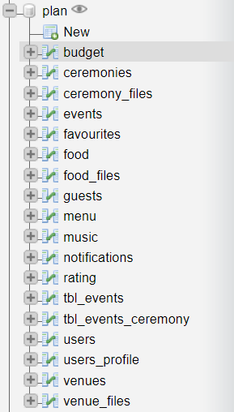

*Figure 22. Database tables for EventSaver application*

To have a distinct description of how the system works in terms of database requirements, it is useful to create an entity relationship diagram (see Figure 23) to graphically represent how data flows within the system.

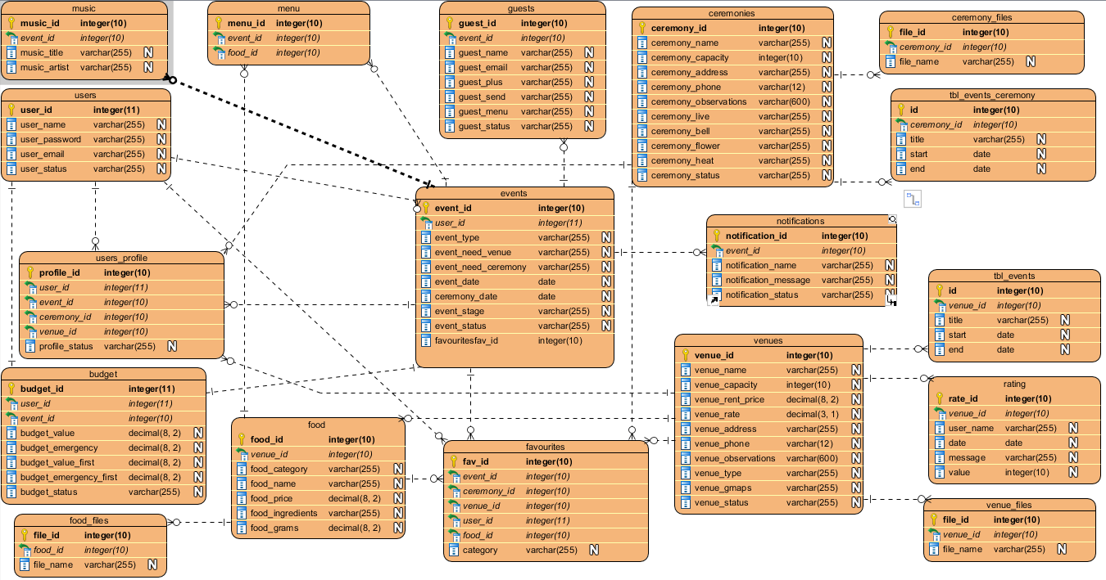

*Figure 23. Data Model (ERD) for EventSaver database structure*

The principal tables represented by the *events* and *users* stay at the basis of the whole project as the result of their implications in many other tables, being indispensable to most of the entities because it is important to know who is the user logged in in the application and on what event they are working on. Without this information, a lot of actions could not be done. For example, to each one of the tables: *music*, *menu*, *guests*, *budget* we must assign the primary key of the *events* table, event_id, in order to know to which event we attribute the actions the users take, otherwise it could not be defined which event the guests need to attend or what menu they will have there. To link all these tables between them, there are used foreign keys.

**4.1.3. XAMPP**

*Figure 24. XAMPP Logo*

For easier availability of technologies and, most importantly, for running PHP on my personal device, I needed a HTTP server. I chose XAMPP because it inherits not only a HTTP server, but also PHP, MySQL and phpMyAdmin, exactly the technologies that I have been enumerating earlier in the documentation as being the most important part of the implementation stage of the project. Therefore, instead of downloading each one these technologies and making the connection between them, XAMPP offers an easier way by downloading only one program that already contains them all.

As a definition, XAMPP is an Apache distribution that consists of a full, most common package of tools needed in web development and it is available for free, fitting in perfectly for students who are learning or who want to create a demonstrational application like this one. It can be downloaded on any main operating system platform (Windows, Linux and OS X) from the official website [*https://www.apachefriends.org/index.html*](https://www.apachefriends.org/index.html), while it will take up only 17 MB of RAM. [10] The link will download a ZIP archive (in Windows, which is the operating system this project was developed on) and the users need to unzip it in a specified folder. XAMPP also comes with a control panel, found after unzipping the archive, where the apache and MySQL servers can be started or stopped. Once XAMPP runs on the computer, PHP based websites can run locally by accessing in any web browser the link [*http://localhost/*](http://localhost/) and at the same time access phpMyAdmin using the link [*http://localhost/phpmyadmin*](http://localhost/phpmyadmin)*.* Initially, users can enter without a set username and password.

**4.1.4. GitHub**



***Figure 25. GitHub Logo***

As nowadays, back-up is more important than anything, any project needs to have a copy stored somewhere. One of the best ways to do that is by using Version Control with Git.

Git is a back-up strategy tailored for any projects, but predominantly for coding ones and it includes version control or managing revisions, perfect for making sure that in a world where data can be so easily lost, it will remain safe and also for teams working together on same files because of the PUSH and PULL functionalities that merges together data from more users. [11]

GitHub is an open source web platform that stands as an interface for Git and that hosts these projects and offers its users the possibility to use version control. It also provides access to other public projects owned by other users. [12] It is easy to use, fast to understand, one of the original websites of such functionalities, thus the most popular choice and its graphical interface is friendly to any type of user and these are the reason why I chose to work with it and host my project there as a back-up from the version I have on my personal device. The EventSaver source code can be found at [*https://github.com/AnnaBratucu/bachelor*](https://github.com/AnnaBratucu/bachelor), under a private repository and accessed on request.

**4.1.5. Visual Paradigm**



*Figure 26. Visual Paradigm Logo*

“Visual Paradigm is a software tool designed for software development teams to model business information system and manage development processes.” [13]

As it is especially important to have a graphical representation for the development process for further and deeper understanding of the possible problems of the project and how they can be resolved by proposing solutions or alternative paths to take for the desired outcome, all the diagrams created for this project were done using Visual Paradigm. It is a powerful tool that allows users to undertake any action about modelling artifacts using UML.

**4.2. Frontend technologies and tools**

**4.2.1. HTML**



*Figure 27. HTML Logo*

HTML is the language responsible for all of the content made to be published on the World Wide Web. It renders every page using some special tags and tells the browser how to arrange the page with some set of instructions. [14]

**4.2.2. CSS**



*Figure 28. CSS Logo*

Whilst HTML renders the content on the page, CSS deals with how the information will be rendered, how it will look like. In one word, it is called the style. [15]

**4.2.3. Bootstrap**



*Figure 29. Bootstrap Logo*

Bootstrap is a framework of design for web applications. It is used for styling the elements rendered on the page easier and faster and it comes with a series of different styles for buttons, forms, modals, etc. [16] and I have used it for a better and responsive design in the application interface. It also gives a great opportunity for a user friendly implementation of style.

**4.2.4. JavaScript and jQuery**



*Figure 30. JavaScript Logo Figure 31. jQuery Logo*

JavaScript provides a way in which the user can have access to dynamic actions in the interaction to the application. In other words, it creates scripting access of the website to the server and, alongside CSS, it stays at the core of the dynamic design of web platforms to this day. [17]

For a simplified version, jQuery was invented as a library of JavaScript that will solve the first’s problems. First of all, jQuery comes in help for web designers, being easy to use than JavaScript, which is still a programming language, harder to understand for some. In other words, jQuery can write in one line of code what JavaScript could in much more. It has more undersandable functions and clearer logical order. Secondly, jQuery solves issues of discrepancy between web browsers as it is known that JavaScript behaved differently on them, but jQuery comes and unifies the appereance and performance on all web browsers. [18]

I used both of them for EventSaver implementation for the tasks such as form validation or different style approaches for carousels and image sliders, but most impotant they were helpful in combination with Ajax.

**4.2.5. Ajax**



*Figure 32. Ajax Logo*

Ajax is a combination between JavaScript and XML and being asynchronous, modifications are done almost instantly, which is a big goal for web development and the user interaction with the website increases in efficiency. [19] Since Ajax can update a web page without refreshing it and can communicate with the server, it was a perfect choice for my application, for functionalities like event calendars and the CRUD functionalities that can be opperated on it, modals or map markers for venue locations.

**Ch. 5: EventSaver web application**

**5.1. Description**

Summing up what has been already discussed in this paper, EventSaver comes as a proposed solution to the problems presented, trying to gather both user feedback and the observations made by comparison with other applications, so there is an assurance that some improvements are made in this field in contrast with the existing applications.

We have already established that in regards of event planning, web applications lack some certain features or are not helpful enough. Taking into consideration that big events in everyone’s lives are the most memorable moments too, it is time to give sufficient attention to making the whole process easier and facilitate human interaction when it comes to organizing events that require many people involved and many preparations.

Without further due, EventSaver is a web application that uses PHP as a back-end implementation programming language and which serves as a platform to mediate users’ access to the vendors they need for an event and ease the planning process through a series of functionalities that involve their budget management, seating arrangements or invitations. These may seem as unimportant, but together they form a list of actions that start becoming stressful when placed in front of an important approaching celebration in someone’s life, that anyone would desire to be perfect. All these aspects can be found in a single place, on the EventSaver application, that can be accessed using any usual web browser and, therefore, it is available to anyone with Internet connection anytime, on any device. This application will give its users the possibility to generate, save and send personalized invitations, arrange guests, book venues and much more. All while keeping track of the money spent and having some statistics on their complete activities on the website.

This being said, the most important actor involved, defined by the platform will be the event organizer, but there will be a second actor in the role of an administrator who will be in charge of the additional changes made upon the list of contracted vendors who will be appearing on the website.

**5.2. Software Actors, Use Cases and Scenarios**

The software will be accessed by two types of users. Consequently, there will be two types of accounts: one for the administrator, which will be called Admin and one will be an usual account, that can be created by the general public who needs to organize an event and, further on, they will be called Planners. The following use case diagram is a visual representation that suggests exactly how the interaction with the system will be done according to each type of actor.

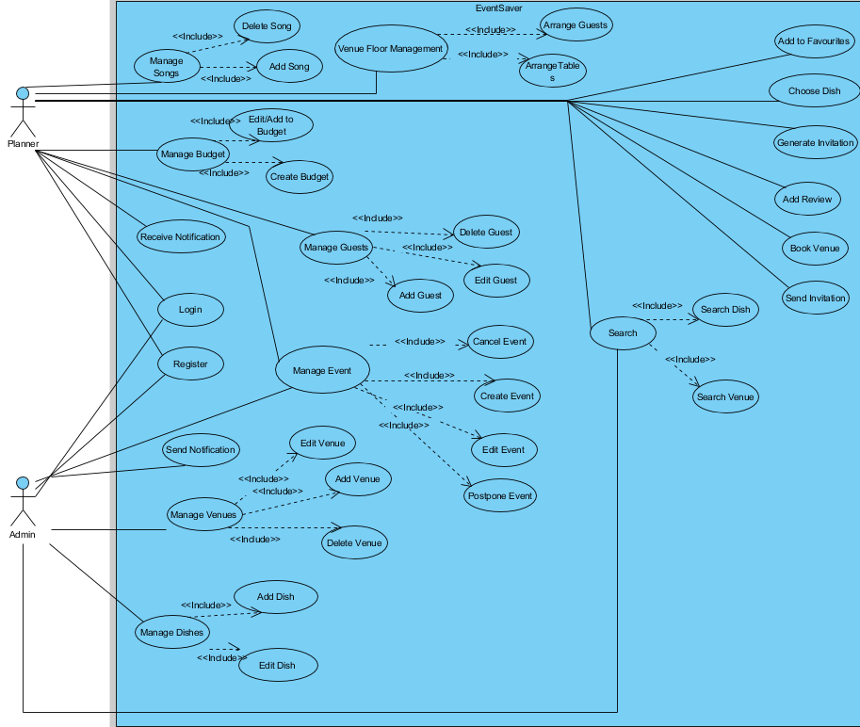

*Figure 33. EventSaver Software Use Case Diagram*

Each actor has its own role in the system. The administrator handles the management of partner venues. In other words, after a new vendor requests to appear on our website and work with EventSaver, the admin needs to add the new venue and its specifications and add already booked dates of other events that will happen there, just so we protect our users from overlapping other event previously settled or settled from other sources. This happens for both ceremony and after party venues. For restaurants that offer food menus, the admin will enter each dish with their descriptions.

The planner will afterwards benefit from all this and they can book venues, choose the whole menu to be consumed on the events day and use all the other features, such as venue floor arrangement or invitation generation.

**5.2.1. Software Use Cases Description**

I will choose a main flux of functionalities to describe in more detail, also considering the conditions that need to be fulfilled so the respective use case can finish in a success state. The use cases I will extract can be found in the Use Case diagram from above and I will present them as follows:

**Login**

* Use case name: Login.
* Use case short description: Each type of user should have an account so they can access all the functionalities of EventSaver and Login with it.
* Stakeholders: planners.
* Preconditions: The application is connected to the server and database so the Login information can be accessed.
* Post conditions: The user is found in the database and it is granted access to the entire website.
* Main flow of events:

|  |  |
| --- | --- |
| Planner | System |
| 1. Login |  |
| 1. Enter username and password | 1. Verifies validity of submitted data in the database |
|  | 1. Confirm Login |
| 1. The redirecting page is shown on the screen |  |

* Alternate flow of events: Invalid data after login –> show error –> repeat steps.

**Create event**

* Use case name: Create event.
* Use case short description: Before getting to plan for an event, the users need to create it by selecting what type of event it is and click create to start the first stage of planning.
* Stakeholders: planners.
* Preconditions: The application is running and the planner is logged in.
* Post conditions: The planner user is redirected to the first stage of the planning process of the event they just created.
* Main flow of events:

|  |  |
| --- | --- |
| Planner | System |
| 1. Create new event |  |
| 1. Enter chosen event type | 1. Verifies validity of submitted data in the database |
|  | 1. Confirm event creation |
| 1. The redirecting page is shown on the screen |  |

* Alternate flow of events: The system crashes -> the website need to be accessed again.

**Manage budget**

* Use case name: Manage budget.
* Use case short description: The first step in the planning process is to enter a budget sum so users can keep track of the money spend on other transactions in the later stages.
* Stakeholders: planners.

Scenario 1:

* Preconditions: The application is running and the planner is logged in and the planner has never created a budget schema before.
* Post conditions: The planner adds a budget number and it will be added in the database, while the website will be redirected to the next stage.

Scenario 2:

* Preconditions: The application is running and the planner is logged in and the planner has created a budget schema before, but the stage they are in is one of the first three initial ones, before making any transactions.
* Post conditions: The planner adds a budget number and it will be updated in the database, while the website will be redirected to the next stage.

Scenario 3:

* Preconditions: The application is running and the planner is logged in and the planner has created a budget schema before and the stage they are in is one after the first three initial ones, after making at least one transaction.
* Post conditions: The planner adds a budget number and this value will be added in addition to one existing in the database, while the website will be redirected to the next stage.
* Main flow of events:

|  |  |
| --- | --- |
| Planner | System |
| 1. Add budget |  |
| 1. Enter chosen budget value | 1. Verifies validity of submitted data in the database |
|  | 1. Verifies the stage the user is at |
|  | 1. If they are in the first stage, the system adds the budget record in the database; if they are in the next three stages, the system updates the budget existing in the database with the new value; if they are in the last three stages, the system adds the value to the existing value from the database |
|  | 1. Confirms budget creation/change |
| 1. The redirecting page is shown on the screen |  |

* Alternate flow of events:

1. The event is in the completed stage -> error shown because budget is not relevant anymore.
2. Input budget data is invalid (not numeric) -> error shown -> user needs to complete it again.

**Generate invitation**

* Use case name: Generate invitation.
* Use case short description: Planners can generate invitation using personalized information based on a chosen template.
* Stakeholders: planners.
* Preconditions: The application is running and the planner is logged in and the planner has gone through the stages of booking a ceremony and after party venue.
* Post conditions: The user fills the additional needed information and the invitation is generated.
* Main flow of events:

|  |  |
| --- | --- |
| Planner | System |
|  | 1. Verifies the stage the user is at |
| 1. Choose invitation template |  |
| 1. Enter requested details and photo | 1. Verifies validity of submitted data in the database |
|  | 1. Confirms invitation creation |

* Alternate flow of events: the planner has not chosen a ceremony and after party venue -> error displayed -> user needs to go and book these venues before generating an invitation.

**Venue floor management**

* Use case name: Venue floor management.
* Use case short description: Planners can arrange their chosen venue space with the tables and guests in what order they want.
* Stakeholders: planners.
* Preconditions: The application is running and the planner is logged in and the planner has gone through the stages of booking an afterparty venue.
* Postconditions: The planner leaves the tables and guests in what arrangement they want on the presented floor in the browser.
* Main flow of events:

|  |  |
| --- | --- |
| Planner | System |
|  | 1. Checks if the user booked a venue |
|  | 1. Checks if they have added guests |
|  | 1. Checks the capacity of booked venue and dynamically changes the floor size accordingly |
| 1. Planner arranges tables and guests at tables |  |
|  | 1. Confirms floor arrangements |

* Alternate flow of events:

1. The planner has not chosen an after party venue -> error shown -> they will have to choose an after party venue.
2. The planner has not added guests -> guests will not appear on screen to b arranged -> the user can come back and arrange guests at tables after they add them.
   * 1. **A user scenario**

Let’s consider a new user who creates an account and goes to create a new event. After that, they must follow the application’s flux in order to complete planning the event. In the next part I will present the scenario in which the user can complete an event by going through every stage the application provides.

Every activity should be done in a specific logic order established for a normal course of planning an event. First of all, they must add the value of money they want to allocate to this event. Next step would be to add guests, then to book a ceremony venue, then an after party venue. With all this information gathered, the planner can go and generate the invitations that will contain details about places, dates and hours of the event. With the invitation fixed, the planner goes and sends them to all the guests. The next step is for the planner to arrange the tables on the venue floor and as the guests accept the invitation, the planner can also arrange them at tables. After all of this, the menu can be established and as a last step, a music playlist to be drafted. By this stage, the event date should be reached and the planning can be considered complete.

This data logic flow will be further explained in the next activity diagram:

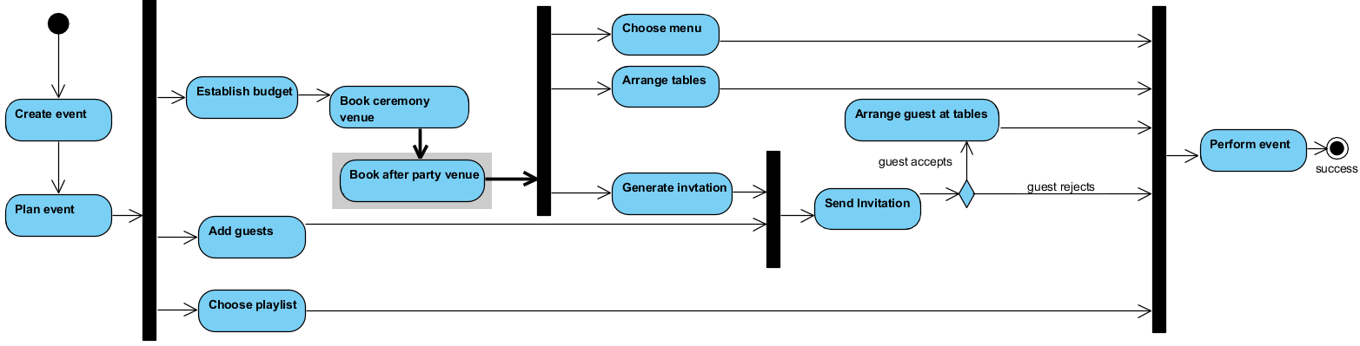

*Figure 34. Activity diagram for EventSaver main flux*

* 1. **EventSaver presentation**

Before an user can access the application’s functionalities, they will be welcomed by a home page with some details about the application.

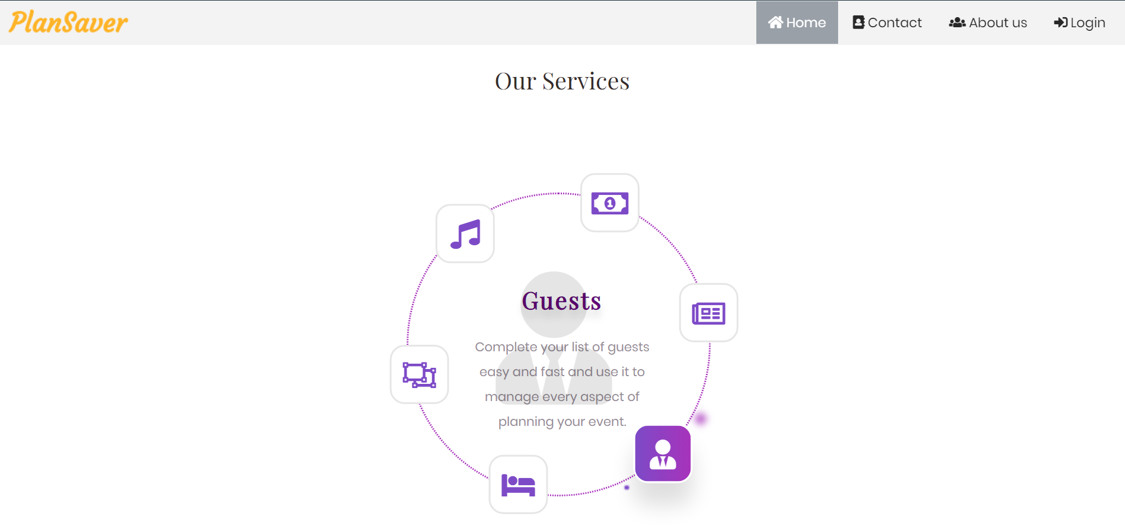

*Figure 35. EventSaver Home page*

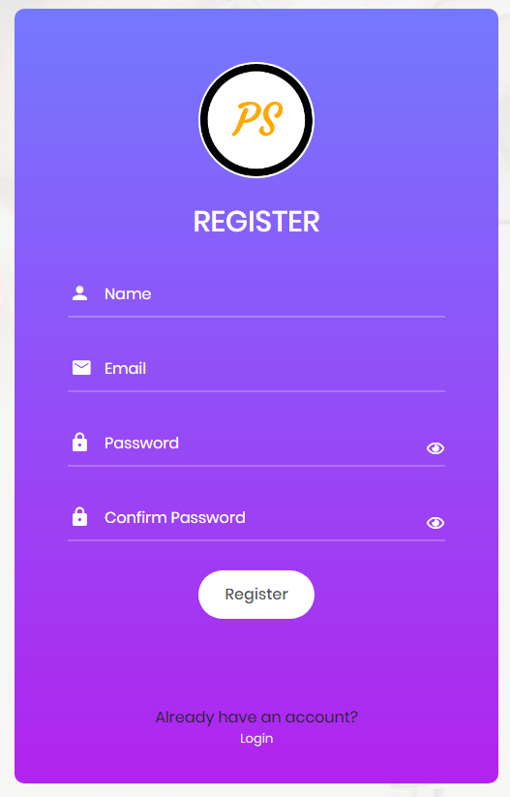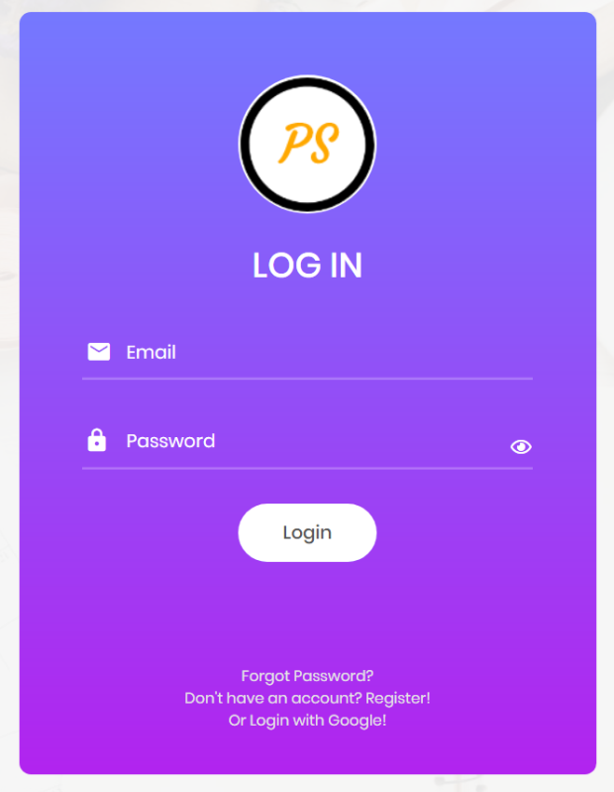 If the user does not have an account already, they can create one, otherwise just Login with their information.

*Figure 36. EventSaver Login page Figure 37. EventSaver Register page*

The user will be redirected to an intermediary page

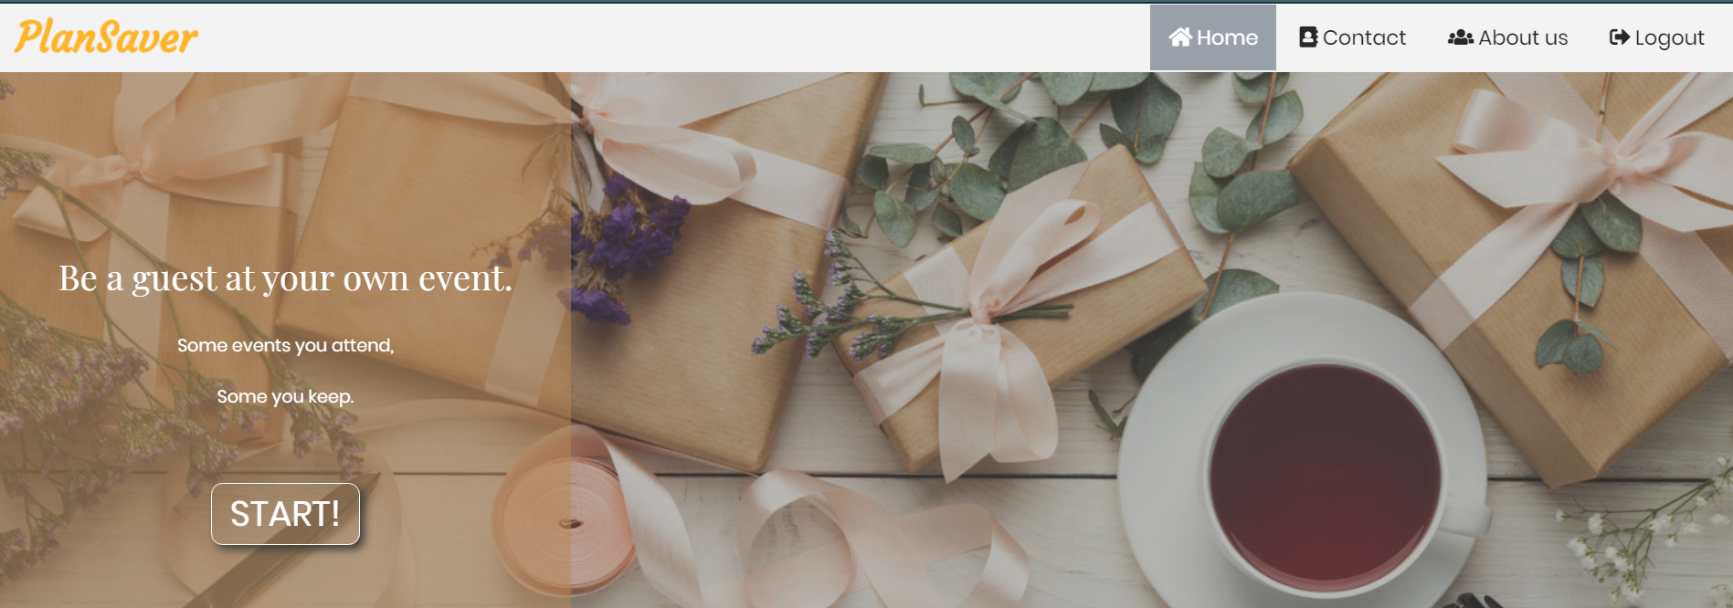

*Figure 38. EventSaver start page*

When pressed the START button, the user will be taken to a page where they need to choose an on-going event they have waiting to be planned or to create a new one.

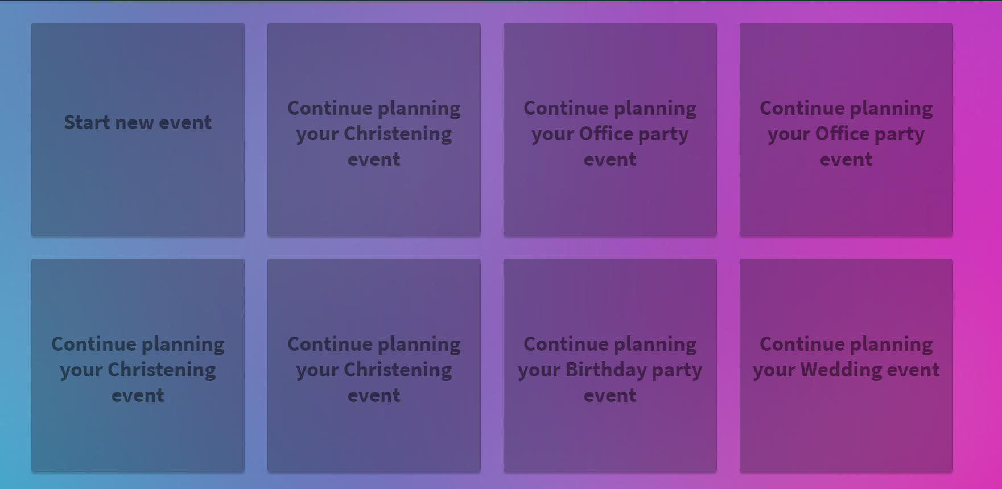

*Figure 39. EventSaver choose what event to plan*

If they choose an existing event, they will be redirected to the event stage they remained at. Otherwise, they will be asked what kind of event they want to create.

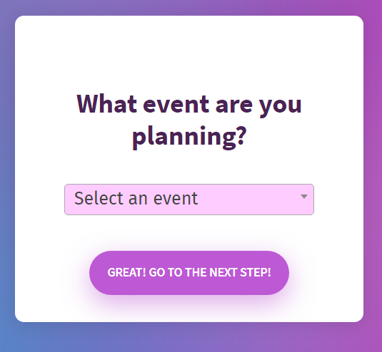

*Figure 40. EventSaver create an event type*

They can choose between the following types of event: Wedding, Christening, Birthday Party, Office Party and Ball.

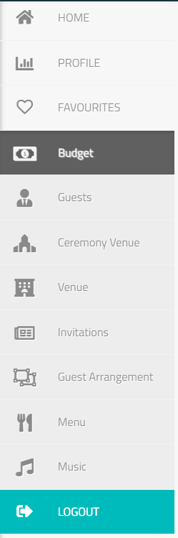 Now there will be a menu on the left side of the page which expands on mouse hover and contains the different stages of the planning process.

The first stage is for the user to complete the budget they want to assign the organization of this event. It does not have to be extremely accurate as it is clear that some might dispose of more money in the future, but the users can update it later on.

There is also an emergency budget they can set optionally from which money will be extracted only in case of main budget being exceeded.

*Figure 41. EventSaver menu*

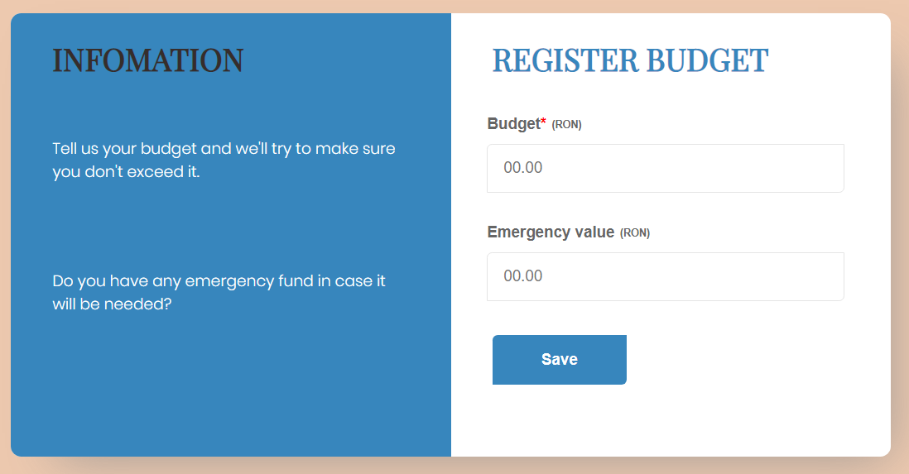

*Figure 42. EventSaver budget stage*

The next stage is to add the guests the planner wants to attend by adding their names and emails so they can send them invitations via mail in future stages. The planner has the option to edit a guest in case of mistakes or delete them if they do not want them on the list anymore. Also, there is an option which allows the user to delete or send invitations to all guests in the list to which an invitation has not been sent yet, without losing time to select one at a time.

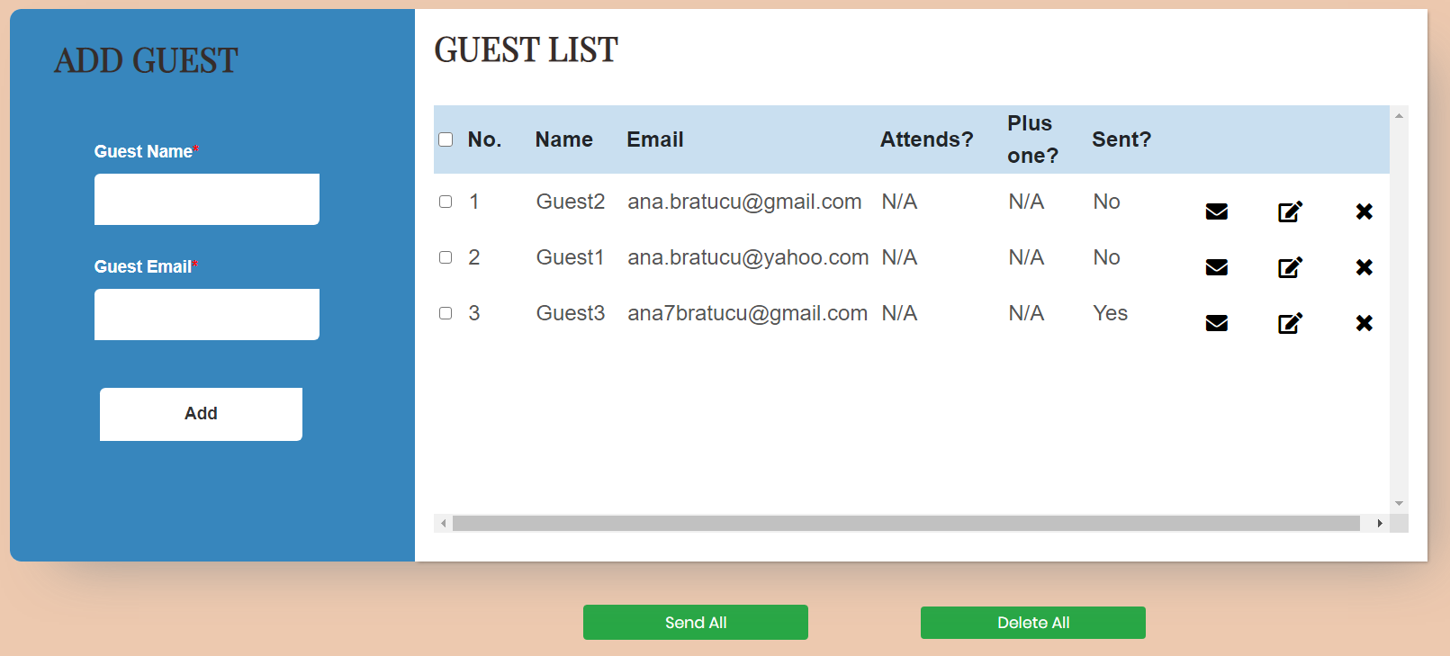

*Figure 43. EventSaver guest page*

For the next stage, where the user needs to book a ceremony venue, they first must select a date interval in which they want the event to take place in order to select only those venues which are available in at least one day out of the interval the user selects. The minimum date needs to be set in the future of the present date, while the maximum date needs to be higher than the minimum one and higher than the present date as well. Furthermore, the user has the option to not choose a venue at all.

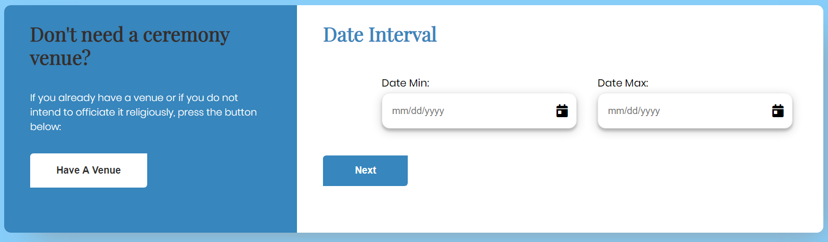

*Figure 44. EventSaver ceremony venue availability date interval*

On the next page, the user will be directed to the list of available venues in that period of time. The user can click on each one and see the details, add them to favourites or search a certain venue by the name or a certain address they want.

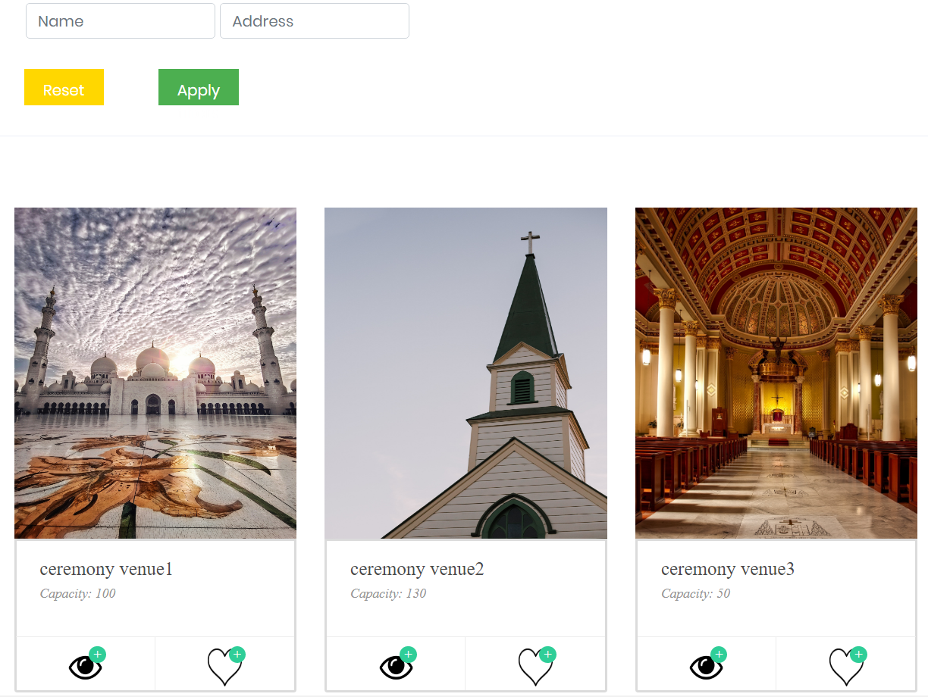

*Figure 45. EventSaver ceremony venue page*

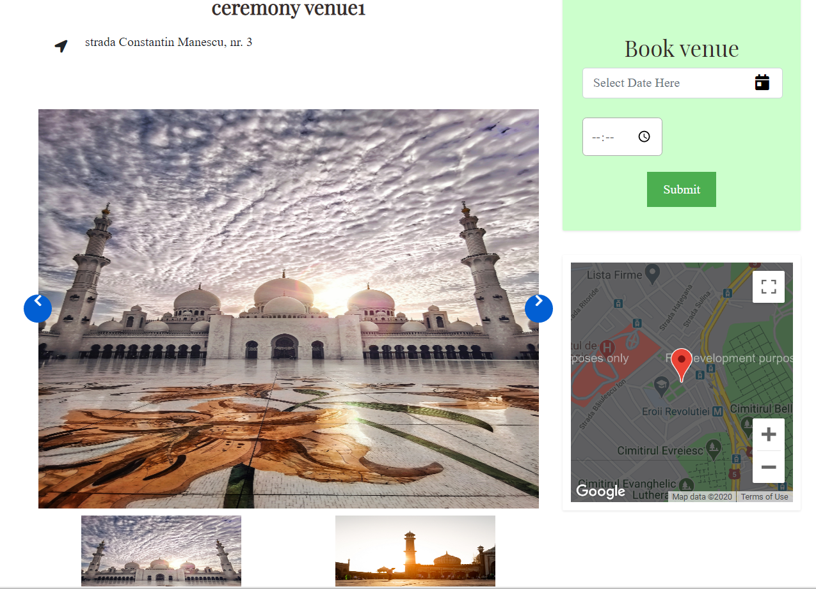

*Figure 46. EventSaver venue details*

By accessing the eye icon, the user will see a page (Figure 46) with all the information about that venue and its pictures, where they can choose a date which is available to pick (meaning that is not already booked) and an hour they could arrive at the venue.

Exactly the same logic of events is used for the after party events, the only difference being the type of specification these venue have, the search criteria and the fact that, by booking such event, it will be subtracted from the user’s budget the sum of money that corresponds to the price of renting that venue.

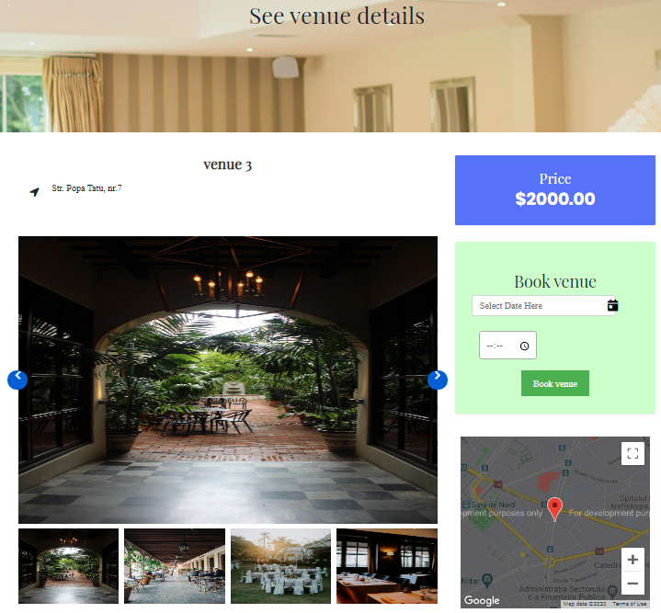

*Figure 47. EventSaver venue details*

A new addition to this type of venues is the fact that it offers the users the chance to write a review of that respective location, which will be added to existing one and the result will be an average, to give other users an overview about other experiences.

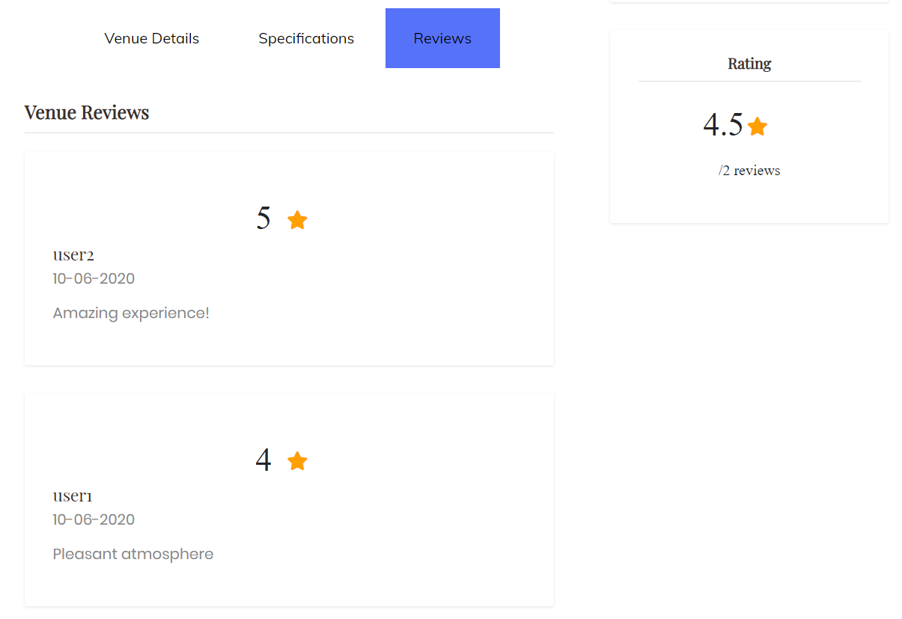

*Figure 48. EventSaver review page*

The next stage is to generate the invitation from a list of given templates and add each personal information needed (such as names and pictures) so that the invitation can be completed in a personalized way.

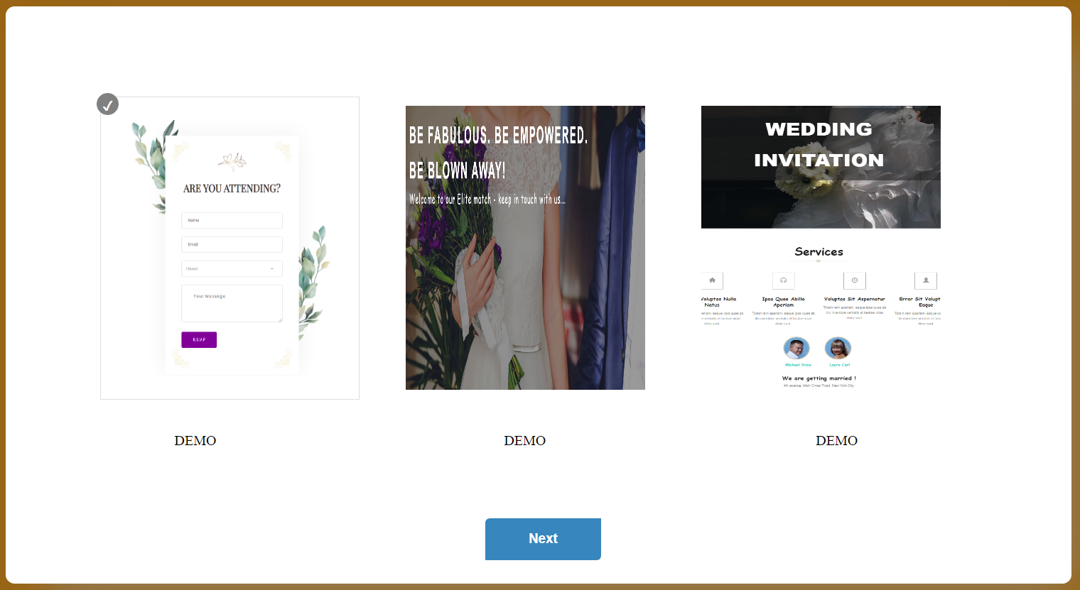

*Figure 49. EventSaver choose invitation template page*

In the context of table and guest arrangement, the number of tables will be updated with respect to the capacity of the chosen venue and the guests who have accepted the invitation sent via mail (the invitation contains a section where the guest can answer) will appear on screen ready to be placed at a table using drag and drop for further reference for the venue organizers who will take care of the floor arrangements.

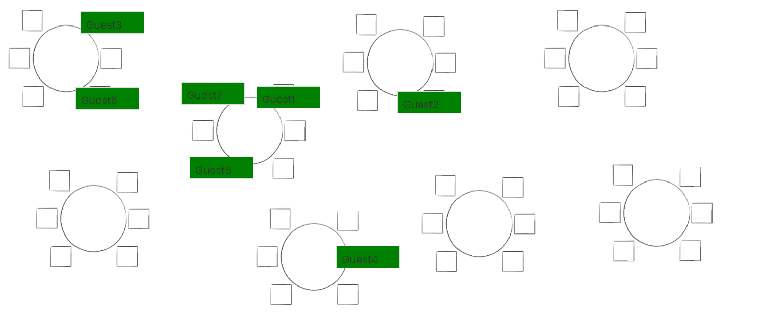

*Figure 50. EventSaver table and guests arrangement page*

When it comes to the menu the guests will serve, the planner can choose every dish and how many meals they want and, in the end, the restaurant will prepare approximately as many as the expecting number of guests extracted from how many responded positively to the invitation.

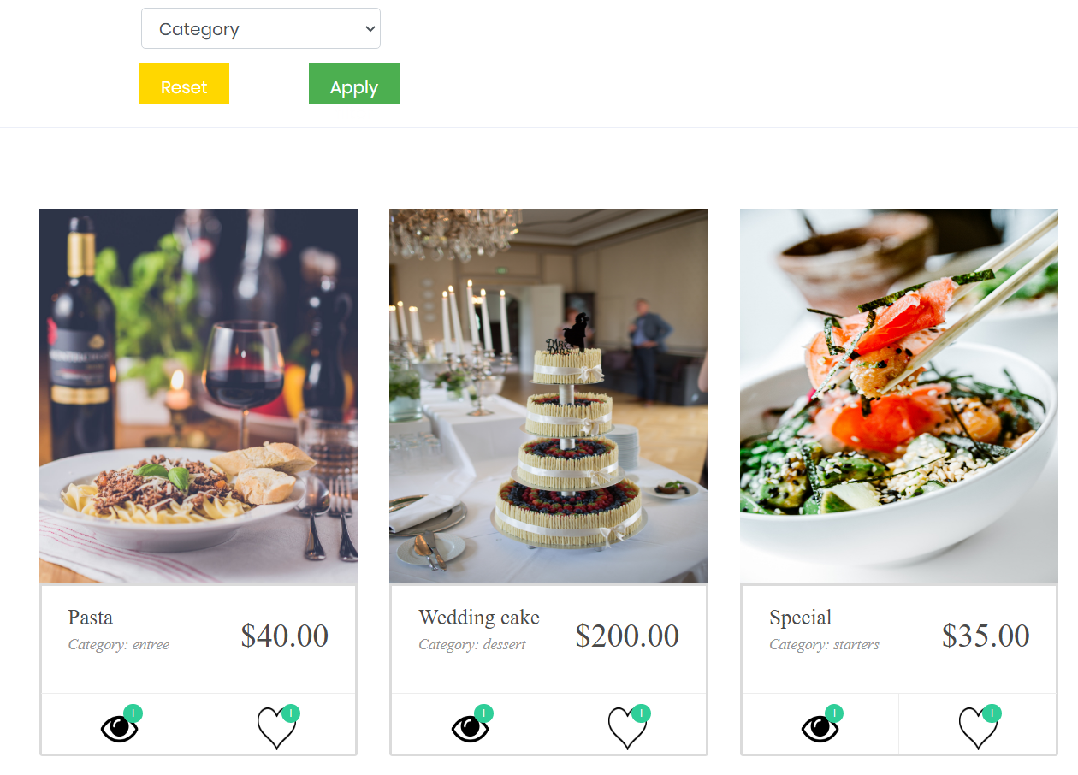

*Figure 51. EventSaver dishes page*

By clicking to see details about each dish, the planner can click on a button and choose the dish to be served at the event.

Last but not least, there is one final step to be completed before the big event, a music playlist. By adding songs to the list, the planner can make sure that the event will have a personalized list of songs to be played.

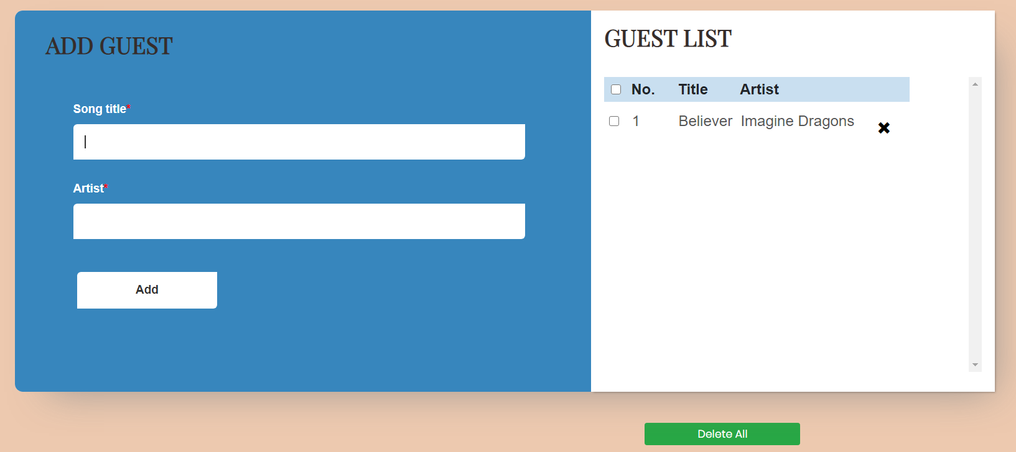

*Figure 52. EventSaver music playlist page*

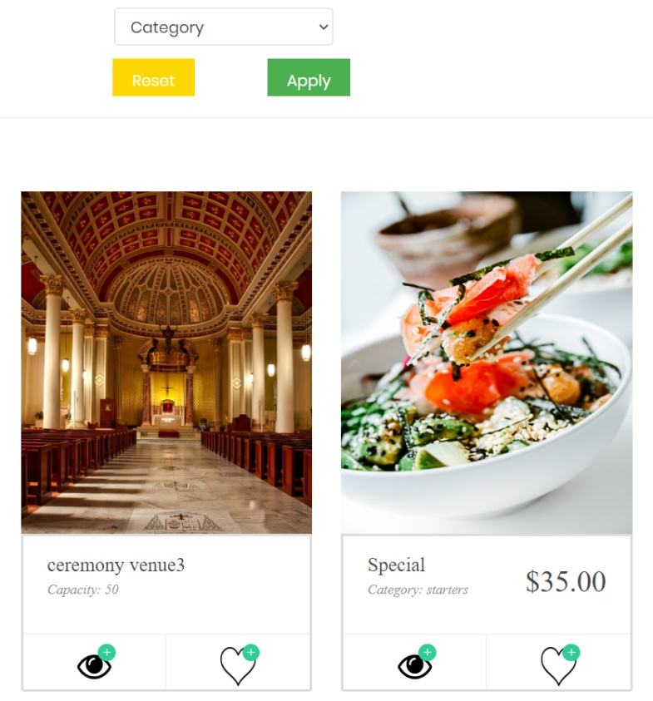 The planner can add any venue and menu to a favourites page for future reference and easier access from a list of personal favourites. This page also contains a search criterion so the user can filter each type of category (Venue, Ceremony Venue and Dish). Every post added to favourites transcends, for each user, the event which is being planned in that moment, so the user can access everything they like also for other events. A venue or dish can only be added to the favourites page only once per user.

*Figure 53. EventSaver favourites page*

To sum up everything that is done during the planning process, a profile page is being placed at the disposal of the user, so they can keep track of the choices they make, statistics regarding guests or manage the event in itself by having the possibility of cancelling or postponing it. This is also the place where the notification centre is that will announce the planner about important decisions that could influence the state of their event.

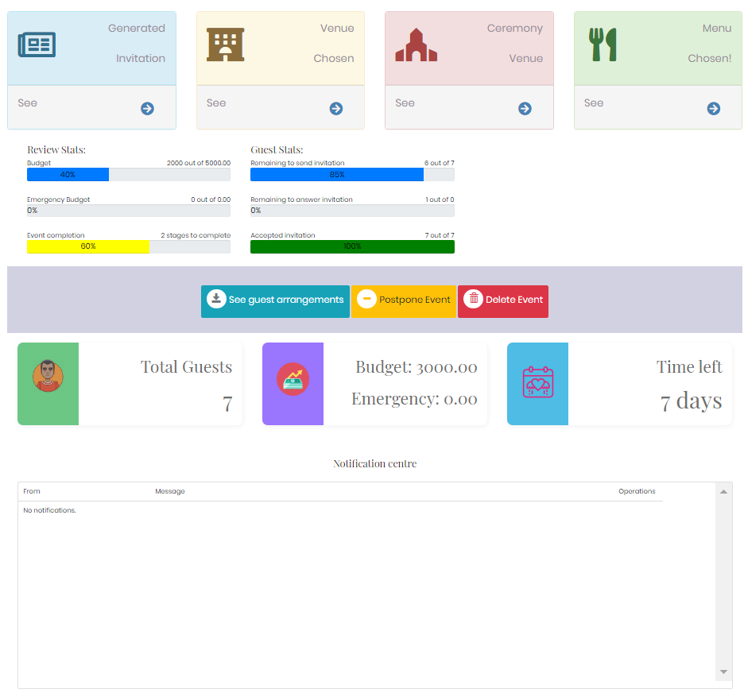

*Figure 54. EventSaver profile page*

There is also important to specify that all the venues and dishes and their respective information are being added, edited or deleted by the administrator or establish event dates. As we have seen previously, the admin role handles this kind of processes, being a mediator between the planners and the vendors with whom EventSaver has contracts.

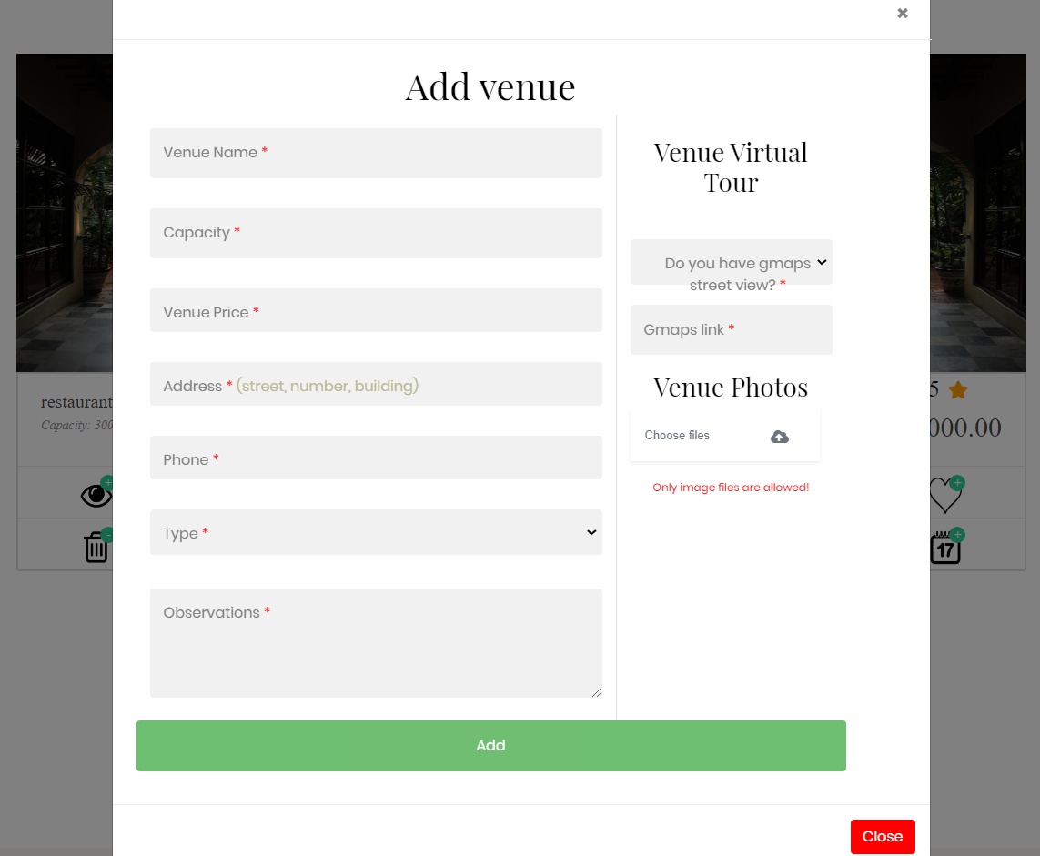

*Figure 55. EventSaver add venue modal by admin*

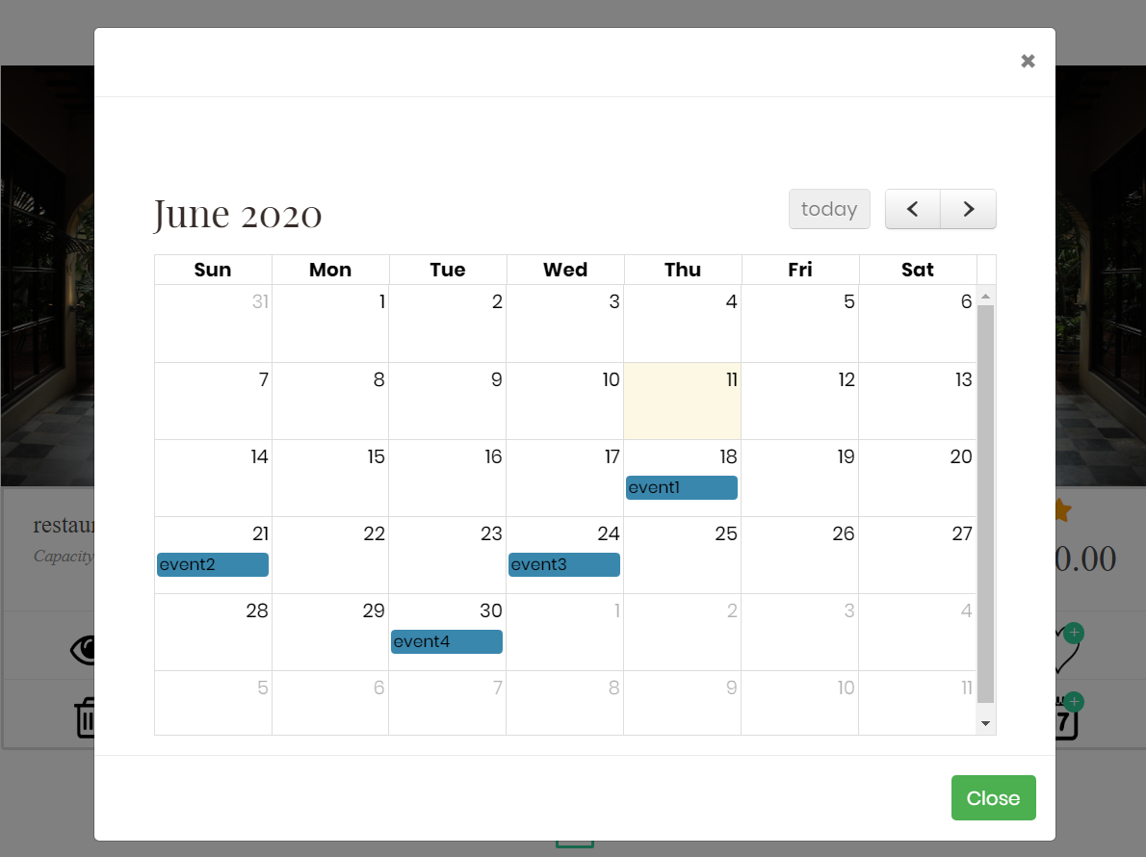

*Figure 56. EventSaver add event dates modal by admin*

* 1. **EventSaver feedback**

As it can be seen in the Annex…, a survey has been conducted in order to receive a feedback on the implemented application presented in the earlier chapters. The questionnaire has been answered by …. people, most of them being the same persons who have previously answered the market research survey from chapter 3.1 so some concluding final ideas can be drawn by comparing what they initially expected from event planning applications to what EventSaver has to offer and if that is fulfilling enough.

The responders have been given all the materials and workspace needed for them to access the application and have tested every functionality, in order for their responses to be as accurate as possible. The majority has answered that EventSaver is a good and useful application from their perspective and that it could be used to save time lost on trivial matters regarding the traditional organizing process. Also most of them have rated the experience on the website from the point of view of the easiness to navigate around with a value of 4 out of 5. As a future resolution, almost all respondents have unanimous agreed that a very helpful functionality that is now inexistent is to have a clothing tab to shop for dresses or costumes.

Taking their answers into consideration, EventPlanner seems to have been reaching certain expectations, but it is still not the best application that could be. Therefore, next I will present the future work that needs to be done for further improving this event planning platform.

**Ch. 7: Further work and Conclusions**

* 1. **Further objectives**

As any other technology, EventSaver is a platform that still needs some improvements. One main goal from the development perspective is to include ore stages to the application flux.

* 1. **Conclusions**

I consider EventPlanner to be an innovating project that could make an impact if put on the market.

**References**

[1] Andrews, E., 2013. *Who Invented The Internet?*. HISTORY. https://www.history.com/news/who-invented-the-internet [Accessed 28 March 2020].

[2] BroadbandSearch.net. 2020. *Mobile Vs. Desktop Usage (Latest 2020 Data)*. BroadbandSearch https://www.broadbandsearch.net/blog/mobile-desktop-internet-usage-statistics [Accessed 28 March 2020].

[3] Petrov, C., 2019. *52+ Mobile Vs Desktop Usage Stats, 2020 - [Mobile’S Overtaking!]*. Tech Jury. https://techjury.net/stats-about/mobile-vs-desktop-usage/#gref [Accessed 28 March 2020].

[4] StatCounter Global Stats. 2020. *Desktop Vs Mobile Market Share Romania | Statcounter Global Stats*. https://gs.statcounter.com/platform-market-share/desktop-mobile/romania#monthly-201902-202002 [Accessed 28 March 2020].

////book

[5] Tatroe, K., MacIntyre, P., & Lerdorf, R. (2013). Programming Php (3rd ed., Vol. 1).

//site

[6] Divakaran, D. (n.d.). Advantages and Disadvantages of PHP. Retrieved from <https://www.phpbabu.com/advantages-and-disadvantages-of-php/>

[7] PHP 7.4.0 Release Announcement. (n.d.). Retrieved from <https://www.php.net/releases/7_4_0.php>

//book

[8] Valade, J. (2010). Php and MySQL for dummies (4th ed.). Hoboken: John Wiley & Sons, Inc.

[9] Delisle, M. (2009). Mastering phpMyAdmin 3.1 for effective MySQL management increase your MySQL productivity and control by discovering the real power of phpMyAdmin 3.1. Birmingham: Packt Publ.

//site

[10] Dvorski, D. (2007, March). INSTALLING, CONFIGURING, AND DEVELOPING WITH XAMPP. Retrieved from <http://worldcolleges.info/sites/default/files/ap5.pdf>

//book

[11] Loeliger, J., & McCullough, M. (2012). *Version Control with Git: Powerful Tools and Techniques for Collaborative Software Development*. O'Reilly Media, Inc.

//site

[12] Finley, K. (2012, July 14). What Exactly Is GitHub Anyway? Retrieved from <https://techcrunch.com/2012/07/14/what-exactly-is-github-anyway/>

[13] FAQ. (n.d.). Retrieved from <https://www.visual-paradigm.com/support/faq.jsp>

[14] Brooks, D. R. (2007). *An Introduction to Html and JavaScript for scientists and engineers*. London: Springer.

[15] Pouncey, I., & York, R. (2011). Beginning Css cascading style sheets for Web design. Indianapolis, IN: Wiley Pub.

[16] Segal, N. (n.d.). 10 Common Uses of Bootstrap. Retrieved from <https://www.htmlgoodies.com/html5/markup/10-common-uses-of-bootstrap.html>

[17] Nixon, R. (2018). *Learning Php, MySQL & JavaScript: with jQuery, Css & HTML5* (4th ed.). Sebastopol (CA): OʼReilly.

[18] McFarland, D. S. (2014). *JavaScript & jQuery: the missing manual* (2nd ed.). Sebastopol, CA: OReilly.

[19] Negrino, T., & Smith, D. (2009). *JavaScript and Ajax for the Web* (7th ed.). Berkeley, CA: Peachpit.